ReedTech

Monday, July 12, 2021

2:35 PM

Login: ghan/Hal***1*****

Email: Gaogao.Han@reedtech.com

Legal Username hang@legal.regn.net

Legal Password - Hal***1*****

Email: hang@LEGAL.REGN.NET

SQL Server Login: sa/Hal***1*****

[MyAnalytics (microsoft.com)](https://myanalytics.microsoft.com/)

8/23/2021

[MyAnalytics (microsoft.com)](https://myanalytics.microsoft.com/?v=network)gh

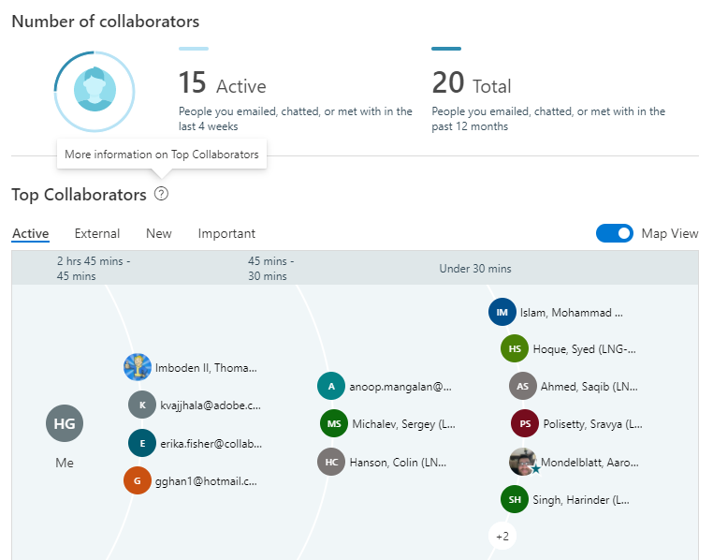

Microsoft Visual Studio Installer Projects

Sunday, August 15, 2021

8:39 AM

[Microsoft Visual Studio Installer Projects](https://marketplace.visualstudio.com/items?itemName=visualstudioclient.MicrosoftVisualStudio2017InstallerProjects)

[**Visual Studio Installer Projects Extension**](https://devblogs.microsoft.com/visualstudio/visual-studio-installer-projects-extension/)

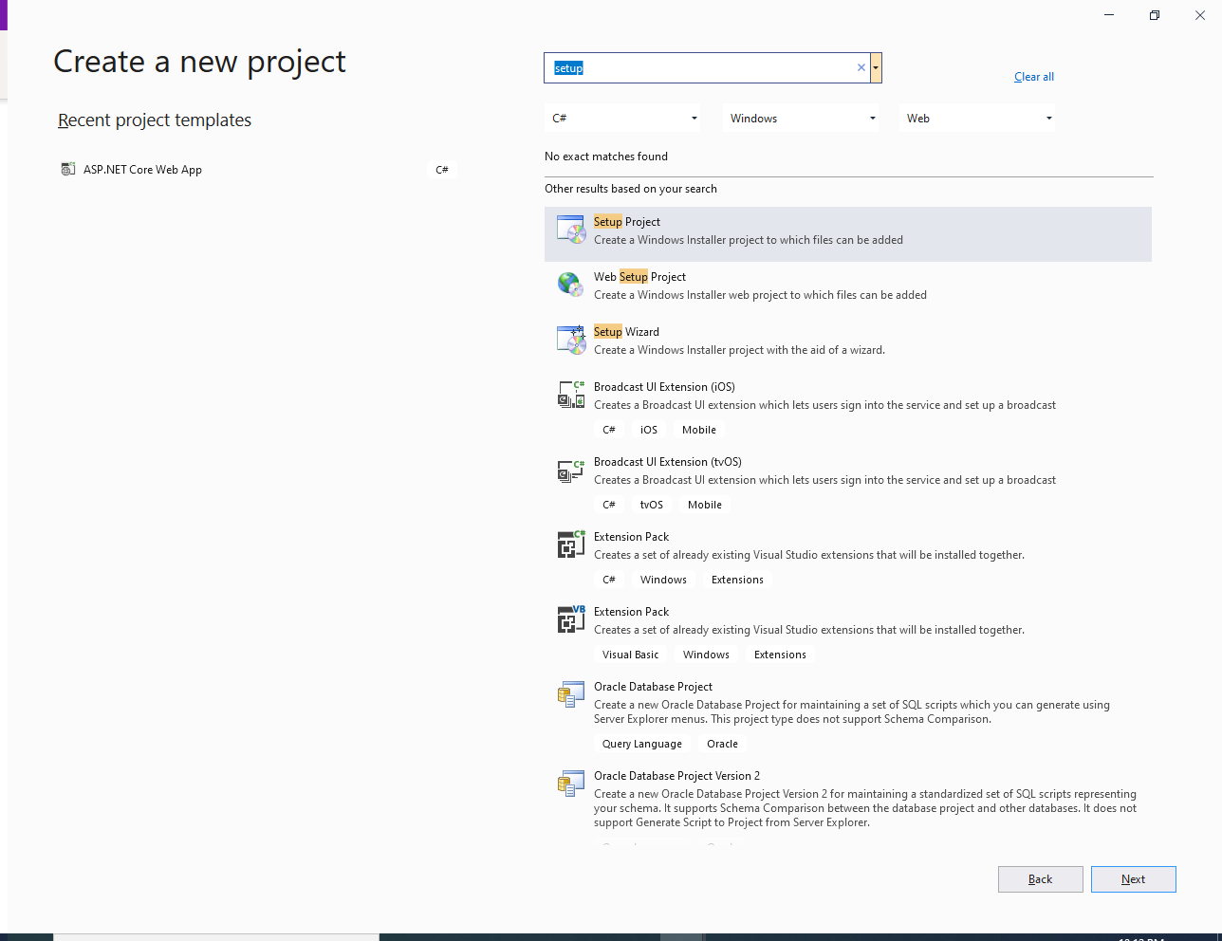

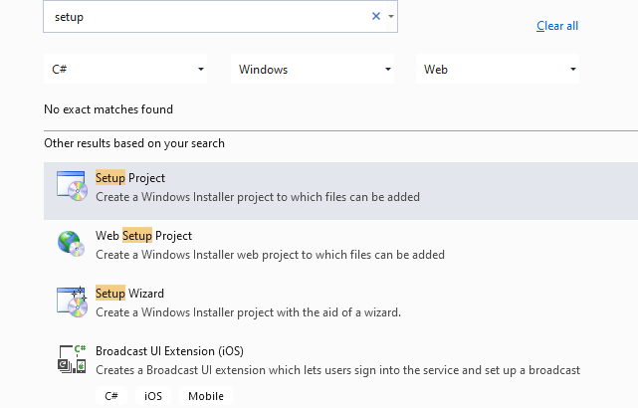

Angular

Tuesday, August 3, 2021

11:07 AM

From [New Developer Setup](https://tfsprod.reedtech.com/tfs/ReedTech/ReedTech/_wiki/wikis/ReedTech.wiki/42/New-Developer-Setup)

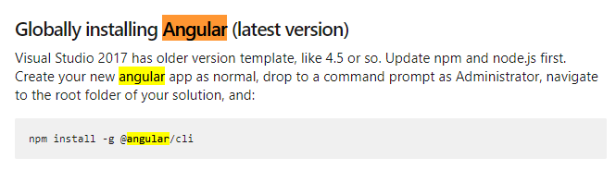

[**Angular and Node.js Setup**](https://tfsprod.reedtech.com/tfs/ReedTech/ReedTech/_wiki/wikis/ReedTech.wiki/590/Angular-and-Node.js-Setup)**:**

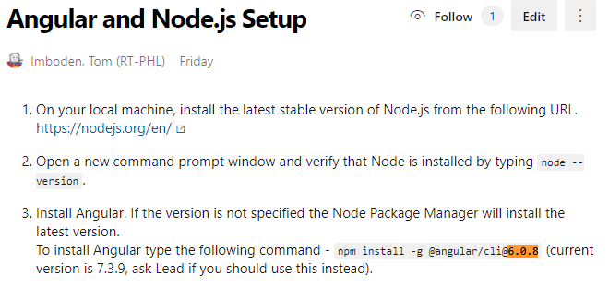

npm list -g --depth=1

npm install -g @packagename

1. Our local machine setup doesn't allow to run any Angular scripts. So, before we start the session we can use the command (Powershell mode, Admin):  
   Set-ExecutionPolicy unrestricted -Scope LocalMachine -Force
2. Navigate to your project directory and run the command npm install.
3. To start the project run the command ng serve
4. After the session is completed we should restore the setup with command:  
   Set-ExecutionPolicy restricted -Scope LocalMachine -Force

*From <*[*https://tfsprod.reedtech.com/tfs/ReedTech/ReedTech/_wiki/wikis/ReedTech.wiki/590/Angular-and-Node.js-Setup*](https://tfsprod.reedtech.com/tfs/ReedTech/ReedTech/_wiki/wikis/ReedTech.wiki/590/Angular-and-Node.js-Setup)*>*

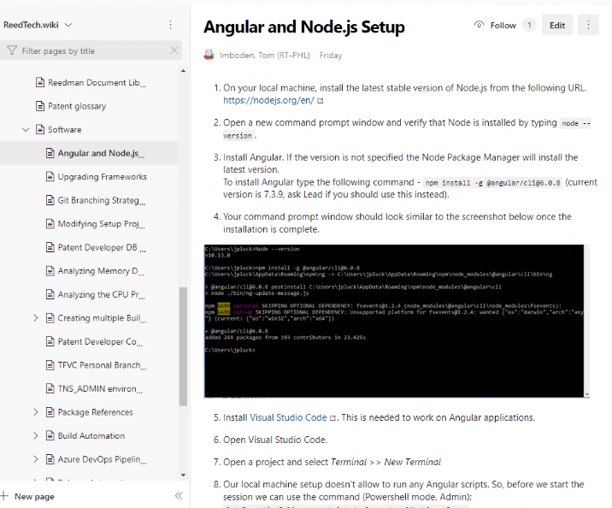

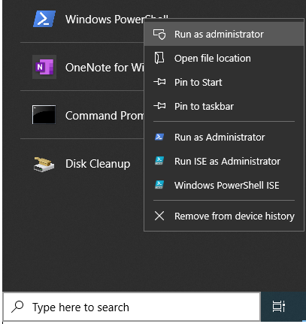

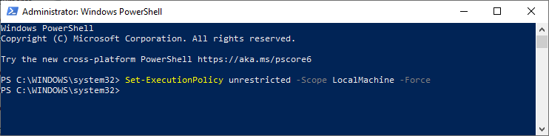

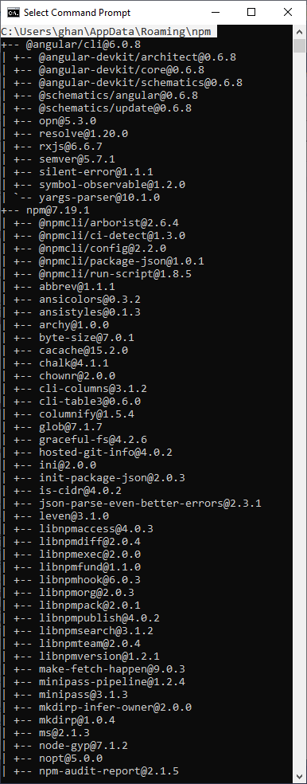

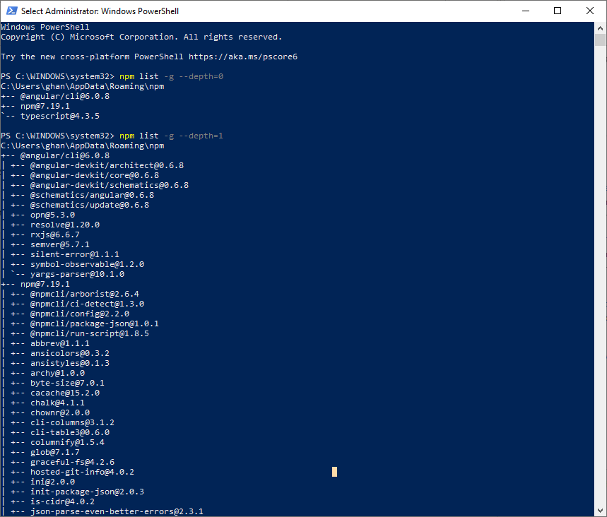

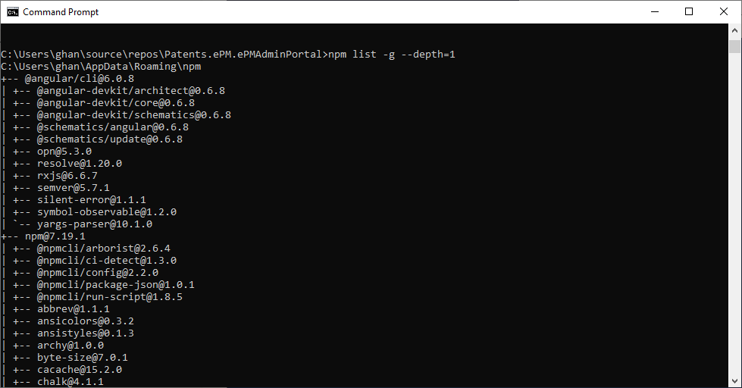

Git Workshop

Thursday, July 22, 2021

From file: Reed Tech git Workshop

 Exercise 1: Configure git

You will learn how to set your user information into git, which git uses for the commit history, and additional items needed for VPN access to DevOps Server/git.

Task 1: Set global git configuration.

1. Open a command prompt using Run as Administrator.
2. Type:  
   git config --global user.name “Firstname Lastname”
3. Type:  
   git config --global user.email “youremail@reedtech.com”
4. Verify your configuration settings. Type:

git config --global -l

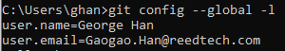

1. Set default pull to local branch from remote to do a rebase. This is so that when you are working on a feature and other developers have been making changes to the remote develop branch, when you pull to update your local develop branch it will fast forward the remotes changes to your local branch then apply your commits. Otherwise, you will see mixed commits and creating a pull request will be harder.  
   git config --global pull.rebase “true”
2. Set fetches from remote to git local remote branches. Otherwise you’ll need remember to use command line to clean up your remotes/origin branches when feature branches are deleted after pull requests are completed.   
   git config --global fetch.prune “true”

**Note:** You may set these global configuration settings from Visual Studio. Open Team Explorer, click **Settings**, and then click **Global Settings** under Git. However, not all global settings are available in the UI, nor are any system or local repo settings. These settings require the command line.

1. Since we are running on Windows, tell git to ignore case in file system. Git, by its origins in Linux, supports case sensitive filenames. This can cause issues if you rename folders or files by just changing case.

git config --global core.ignorecase “true”

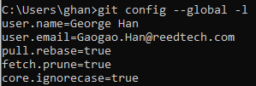

Task 3: Ensure set up for Windows Secure Channel Library connection to DevOps Server

1. Now we will verify that the git system configuration is set to use WSCL connections to DevOps Server.  
   Type:  
   git config --system -l
2. If the entries for http.sslbackend does not exist or is set to “openssl”, we need to fix it. Type:

git config --system http.sslbackend schannel

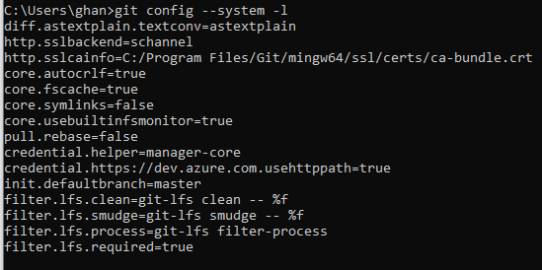

Exercise 2: Configure Visual Studio to access remote git repo

We will manage a connection in Visual Studio that allows us to access our repo.

Task 1: Manage Connections in Visual Studio -- Good

 Exercise 3: Set up to do work on your local machine

Once we have a connection to DevOps Server, we will clone the repository used for this workshop. Clone makes a local copy of the repository, including commit history, and sets up a link between the local repo and the remote repo. Having the commit history means that you can see all changes, from all developers, even when disconnected from the network.

Task 1: Clone the gitWorkshop repo

[Get a copy of a repo fgirom GIT](https://tfsprod.reedtech.com/tfs/reedtech/ReedTech/_wiki/wikis/ReedTech.wiki/234/Using-Git-with-Visual-Studio)

Git installation

Thursday, July 15, 2021

7:58 PM

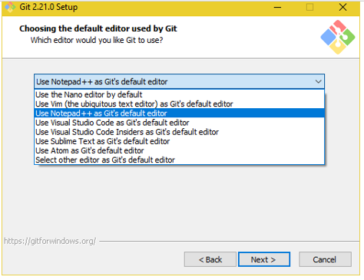

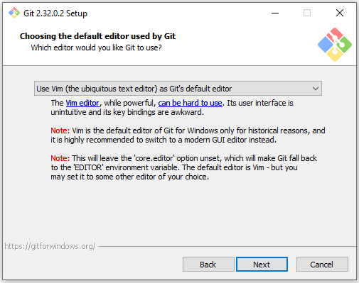

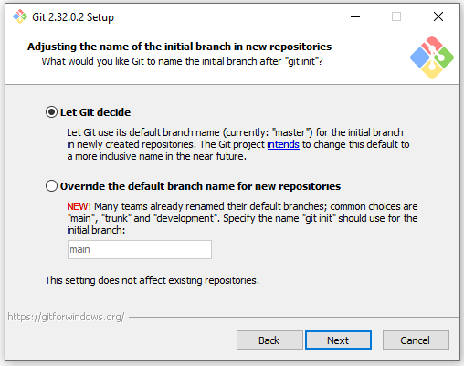

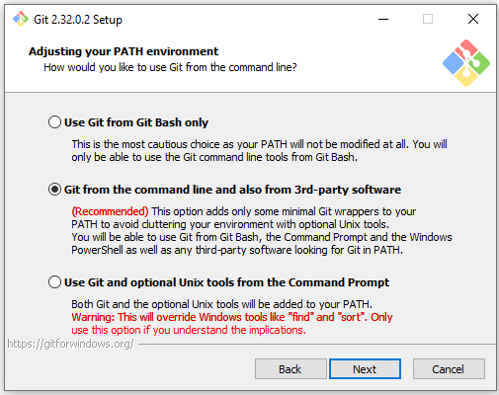

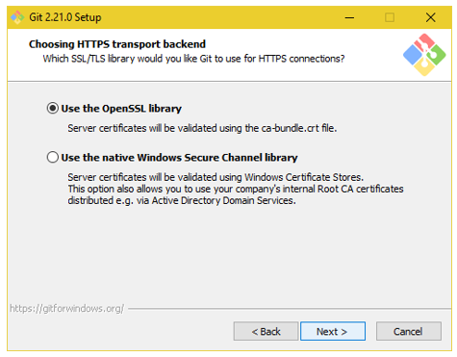

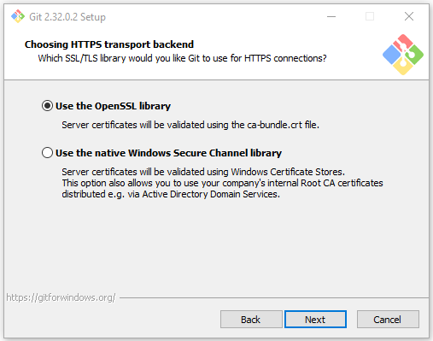

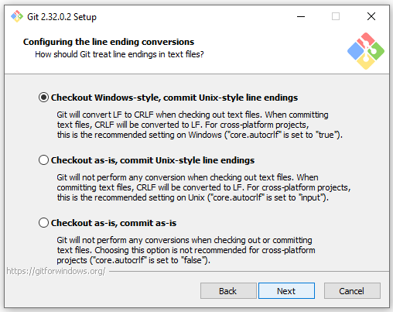

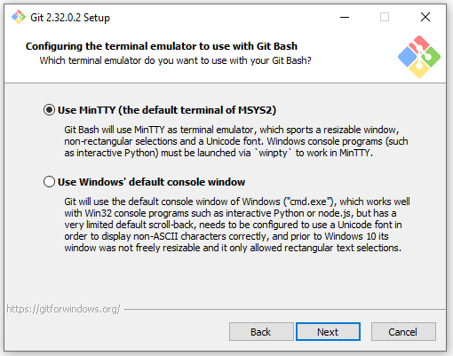

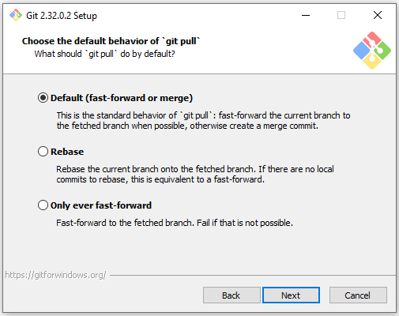

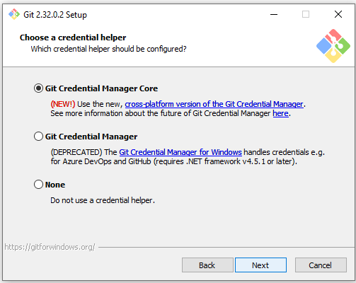

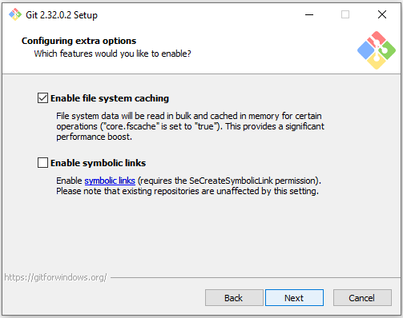

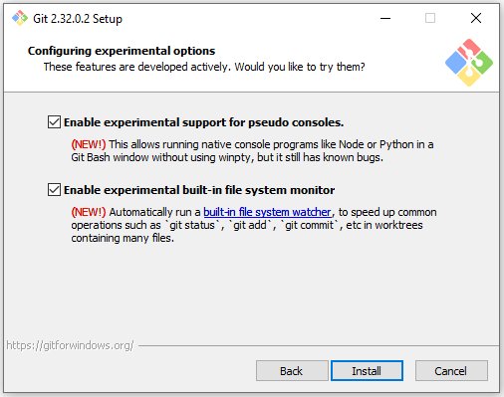

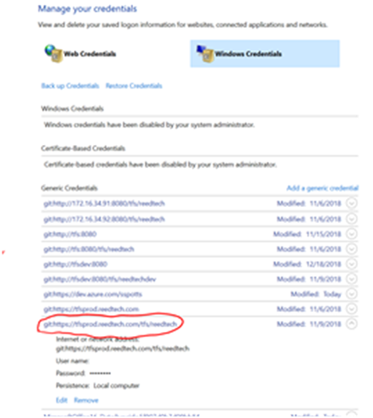

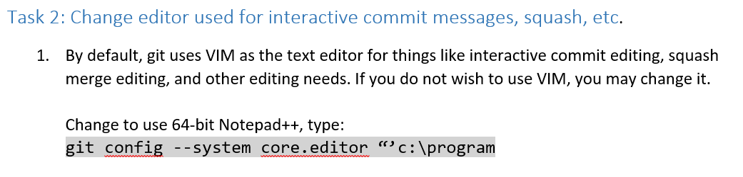

Git Info

Thursday, July 22, 2021

4:17 PM

[Get started with Azure Repos and Visual Studio](https://docs.microsoft.com/en-us/azure/devops/repos/git/gitquickstart?view=azure-devops&tabs=visual-studio)

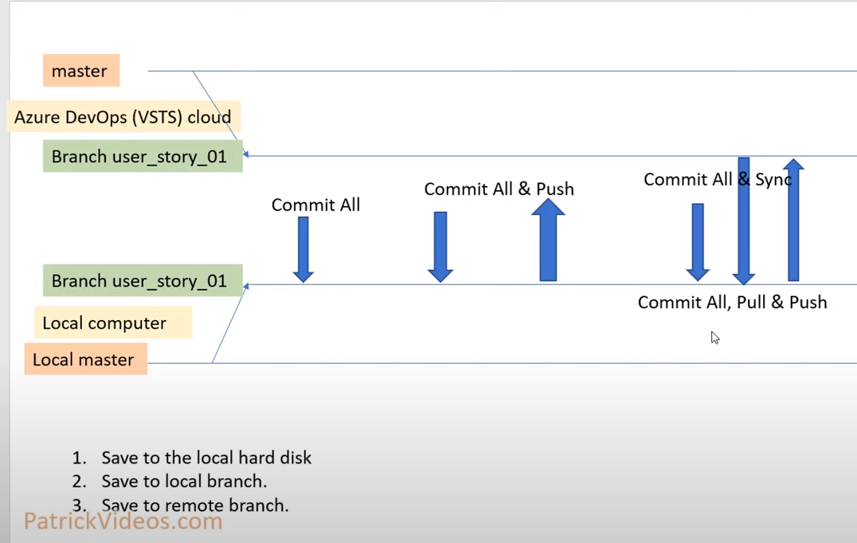

[Git experience in Visual Studio](https://docs.microsoft.com/en-us/visualstudio/version-control/git-with-visual-studio?view=vs-2019)

[GIT and Visual Studio with Azure DevOps Repos - Step by Step](https://www.youtube.com/watch?v=DGOnvqNC9sw)

[Introduction to Git - Core Concepts](https://www.youtube.com/watch?v=uR6G2v_WsRA)

[Up and Running with Git and Visual Studio with Azure DevOps](https://www.youtube.com/watch?v=sntGDmwA7yw)

[Choosing the right version control for your project, Git or TFVC](https://docs.microsoft.com/en-us/azure/devops/repos/tfvc/comparison-git-tfvc?view=azure-devops)

[Create a repository on GitHub from Visual Studio](https://docs.microsoft.com/en-us/learn/modules/visual-studio-github-push/4-create-repo)

[Review history](https://docs.microsoft.com/en-us/azure/devops/repos/git/review-history?view=azure-devops&tabs=browser)

[Get started with Azure Repos and Visual Studio](https://docs.microsoft.com/en-us/azure/devops/repos/git/gitquickstart?view=azure-devops&tabs=visual-studio)

[Side-by-side comparison of Git and Team Explorer](https://docs.microsoft.com/en-us/visualstudio/version-control/git-team-explorer-feature-comparison?view=vs-2019)

[Pricing for Azure DevOps](https://azure.microsoft.com/en-us/pricing/details/devops/azure-devops-services/)

Git

Friday, August 13, 2021

10:05 PM

[**Git Push**](https://github.com/git-guides/git-push)

[**Git Pull**](https://github.com/git-guides/git-pull)

[**push in git**](https://www.bing.com/search?q=push+in+git&cvid=4d364e2c2d6749df81b9780adf4790e4&aqs=edge.0.0l5.4048j0j1&pglt=43&FORM=ANNAB1&PC=U531)

[**pull in git**](https://www.bing.com/search?q=pull+in+git&cvid=dff24eb67e83466097919a8508c389fe&aqs=edge.0.69i59j0j69i57j0j69i60l3.1841j0j1&pglt=43&FORM=ANNAB1&PC=U531)

[**How to commit and push in Git**](https://howchoo.com/www/how-to-commit-and-push-in-git)

[Tutorial: Open a project from a repo](https://docs.microsoft.com/en-us/visualstudio/get-started/tutorial-open-project-from-repo-visual-studio-2019?view=vs-2019&tabs=vs168later)

[**Creating the pull request**](https://docs.github.com/en/github/collaborating-with-pull-requests/proposing-changes-to-your-work-with-pull-requests/creating-a-pull-request#:~:text=Creating%20the%20pull%20request%201%20On%20GitHub%2C%20navigate,the%20topic%20branch%20you%20...%20More%20items...%20)

[**Creating a pull request**](https://docs.github.com/en/github/collaborating-with-pull-requests/proposing-changes-to-your-work-with-pull-requests/creating-a-pull-request)

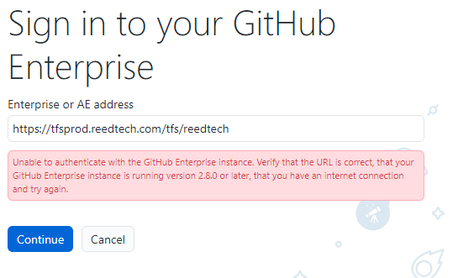

Add an App to Source Control

Sunday, September 5, 2021

5:14 PM

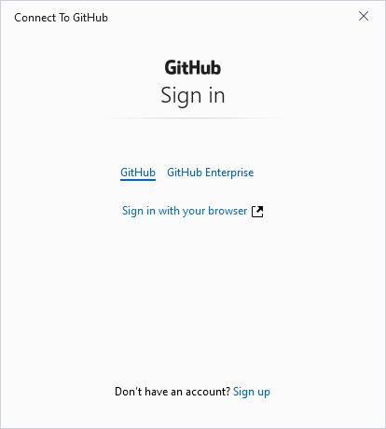

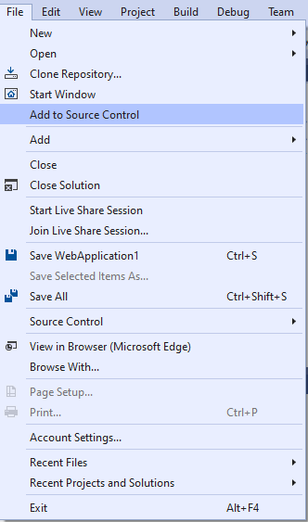

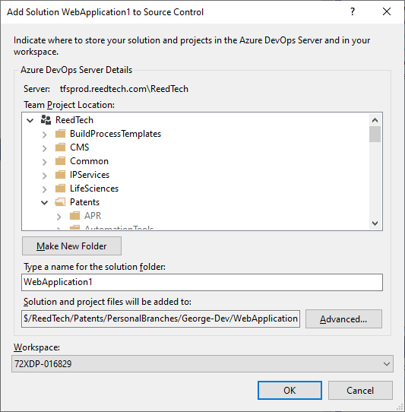

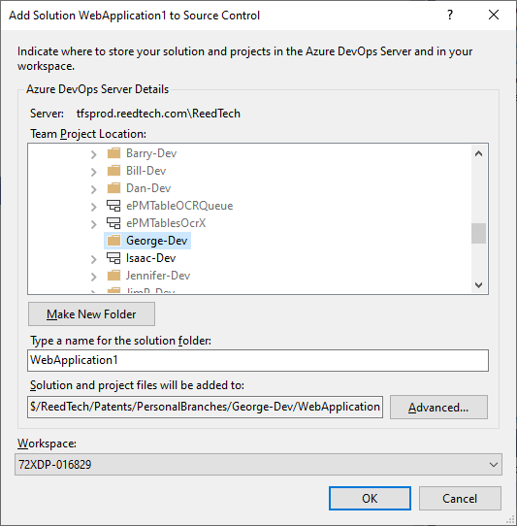

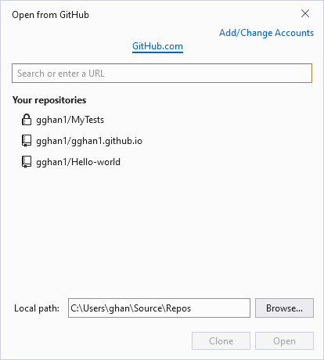

1. Open TFSC

Tuesday, July 27, 2021

10:11 AM

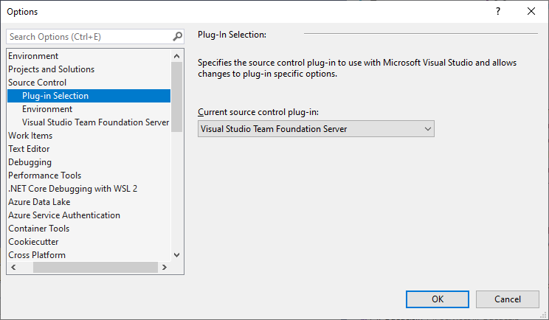

[Connect to projects in Team Explorer](https://docs.microsoft.com/en-us/visualstudio/ide/connect-team-project?view=vs-2019)

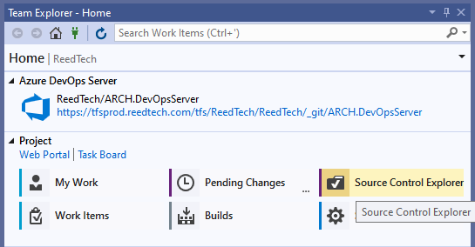

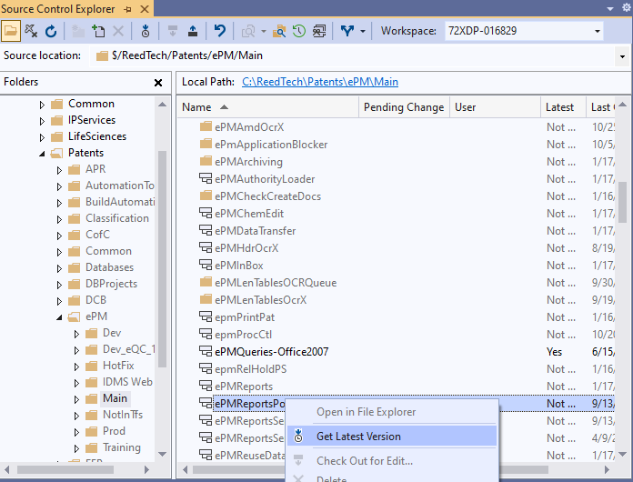

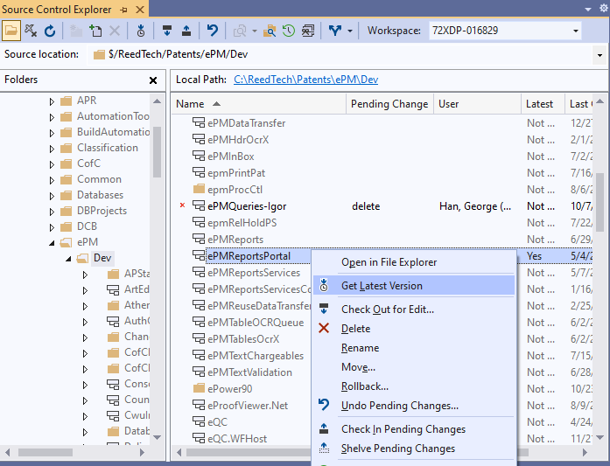

1-1. Comparison: main vs. Dev

Thursday, July 15, 2021

4:22 PM

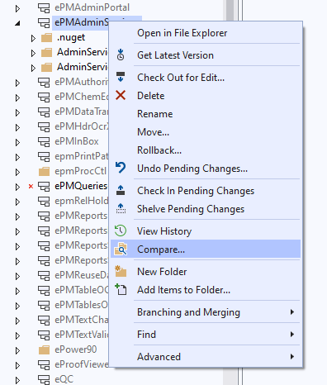

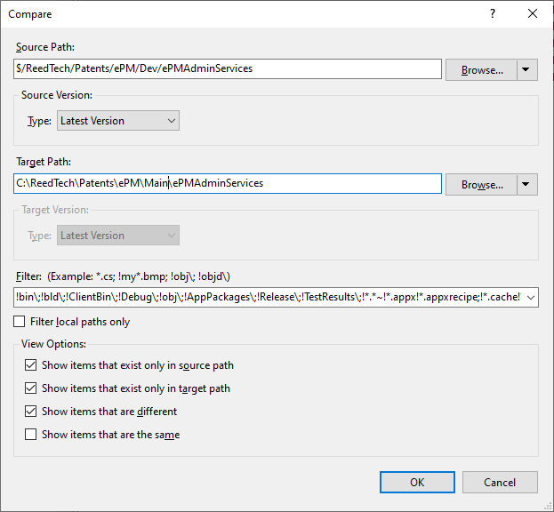

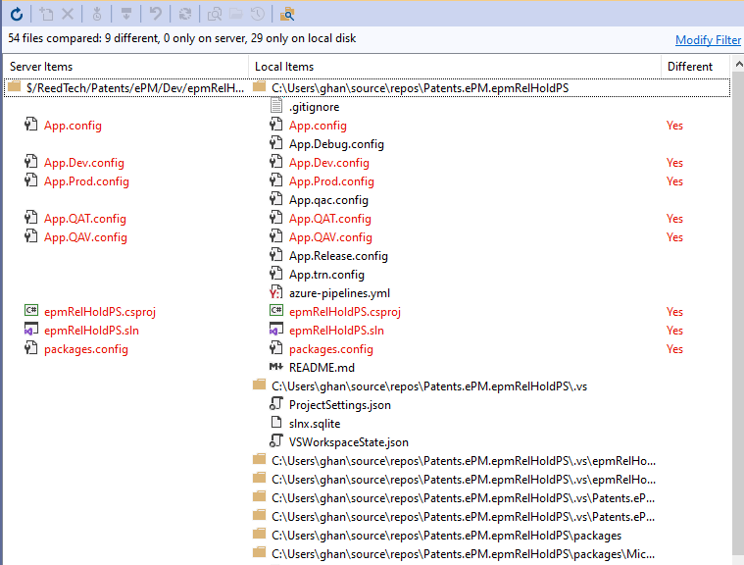

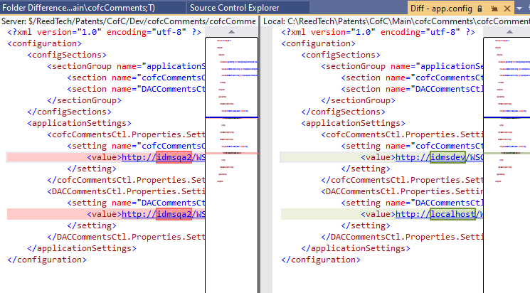

2. TFSC Migrate to Git

Monday, July 26, 2021

9:38 PM

This step will be auto done after CLONE below:

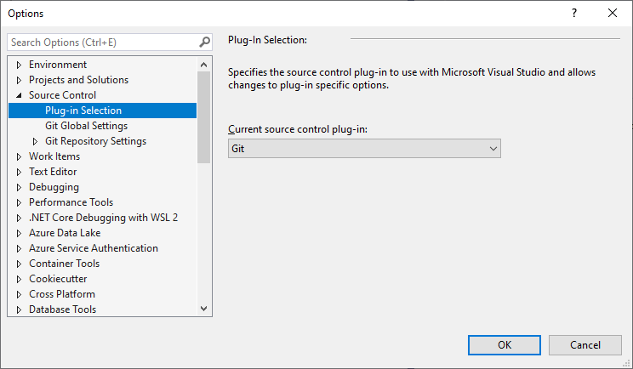

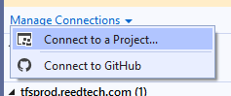

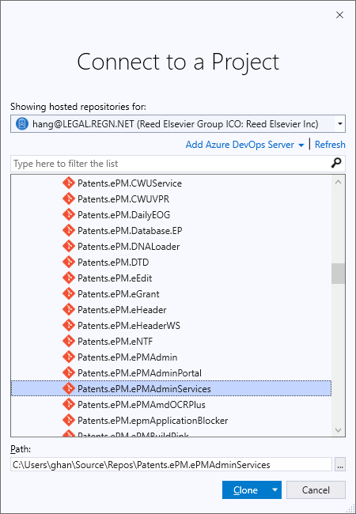

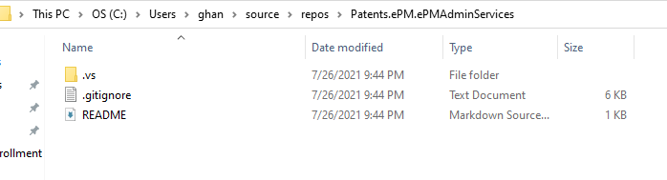

[7/14 11:55 AM] Imboden II, Thomas M. (LNG-HPA)

**First Step - Migration to Git**

General

When you take on a new user story to migrate a project folder from TFS to Git, I think the first thing to do would be to simply copy your files from TFS to Git and commit that to the develop branch with a pull request for approval. From there, you can begin to make the necessary upgrades and other changes outlined in the stories.

There are some concerns with simply moving all the projects files and subfolders to Git because there are certain files and folders we don't want to maintain in Git. Take a look at this wiki for tips:

<https://tfsprod.reedtech.com/tfs/ReedTech/ReedTech/_wiki/wikis/ReedTech.wiki/231/Import-TFVCmig-code-into-git>

The .gitignore file in the repo should help prevent some folders/file extensions from being uploaded automatically, but make sure to update your .gitignore file as suggested int the wiki.

I think some projects may be being updated in the TFS source control first before being migrated to Git. We can choose to do this, but you should also be sending code reviews from Visual Studio for any changes you are saving back into TFS Version Control (TFVC).

We are going to be handling a lot of projects, and it will be hard for to keep track of previous changes for each project while reviewing. If all these changes are done in one repository, the history will be easier to review if needed. As we continue to upgrade, we should be recognizing patterns and expectations which will help us completing more stories more quickly.

What does the group think?

(1 liked)

<<https://teams.microsoft.com/l/message/19:3w-tRdehEKIcruSgcypgMaU5OzROuMTZWah_1IdJLFY1@thread.tacv2/1626278110886?tenantId=9274ee3f-9425-4109-a27f-9fb15c10675d&amp;groupId=13c70e6c-bd72-40dc-b224-2a245bc95fc3&amp;parentMessageId=1626278110886&amp;teamName=OG-RT-Patents-STIG&amp;channelName=General&amp;createdTime=1626278110886>>

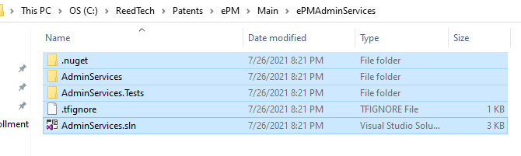

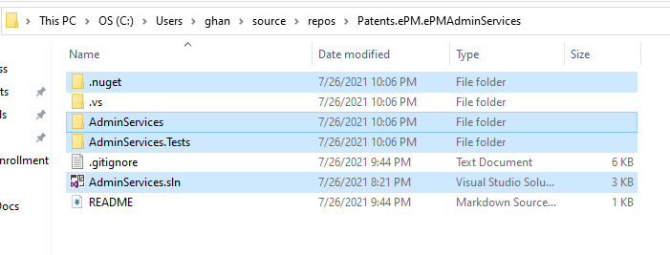

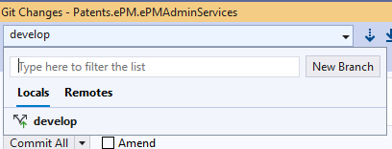

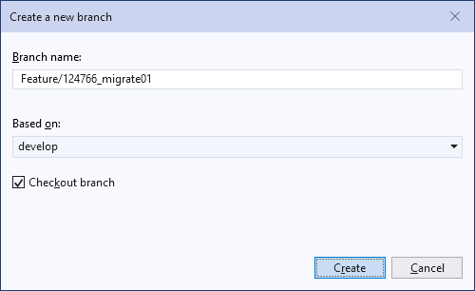

Stage All

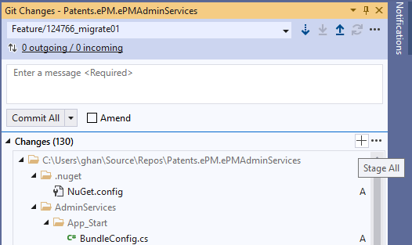

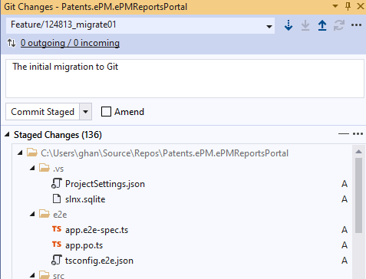

Commit All

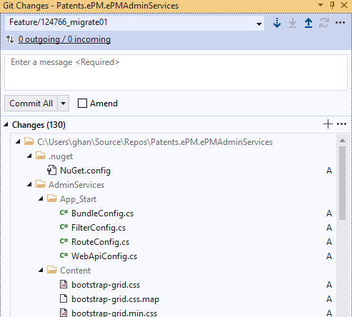

[Import TFVC code into git](https://tfsprod.reedtech.com/tfs/ReedTech/ReedTech/_wiki/wikis/ReedTech.wiki/231/Import-TFVC-code-into-git)

* Make sure the repo gets organized according to our standardized [new project architecture](https://tfsprod.reedtech.com/tfs/ReedTech/ReedTech/_wiki/wikis/ReedTech.wiki/540/New-Project-Architecture).

1. Check changes into the GIT repo
2. Make sure the solution compiles / builds (checking in any changes made to get it working)
3. Push the changes and create a pull request
4. Once a reviewer has approved it, you can manually complete the request or auto-complete on approval.

*From <*[*https://tfsprod.reedtech.com/tfs/ReedTech/ReedTech/_wiki/wikis/ReedTech.wiki/231/Import-TFVC-code-into-git*](https://tfsprod.reedtech.com/tfs/ReedTech/ReedTech/_wiki/wikis/ReedTech.wiki/231/Import-TFVC-code-into-git)*>*

* Upgrade any project references
  + If pointing to non-NuGet, non-Framework components, install the package from NuGet
  + Update any installed “RTIS” NuGet packages to point to the latest “RTIS” NuGet package
    - Try to get latest version from “.main” or “.master” branch with version date after “21.5.x.x”
    - Otherwise, use latest “.develop” branch package found.
  + Use extreme caution upgrading non-RTIS NuGet packages. We do not want to change program behavior or coding.

*From <*[*https://tfsprod.reedtech.com/tfs/ReedTech/ReedTech/_boards/board/t/STIG/Stories/?workitem=124766*](https://tfsprod.reedtech.com/tfs/ReedTech/ReedTech/_boards/board/t/STIG/Stories/?workitem=124766)*>*

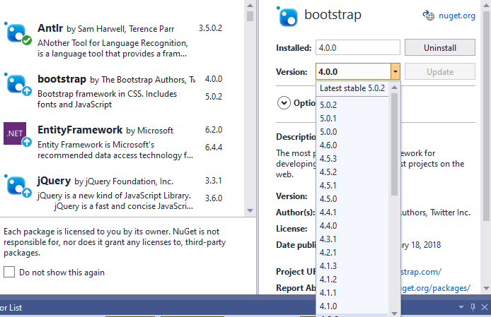

Open a previous project:

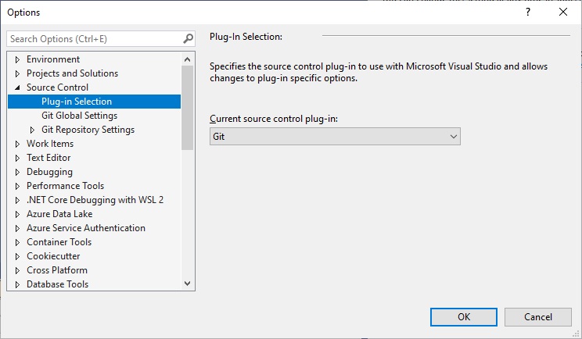

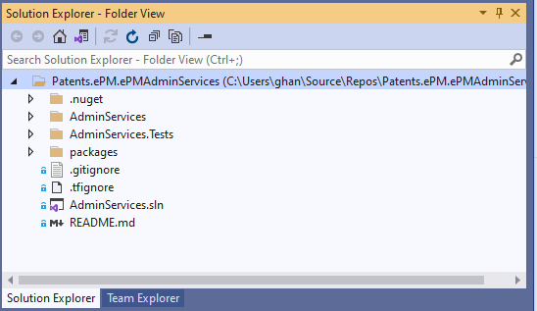

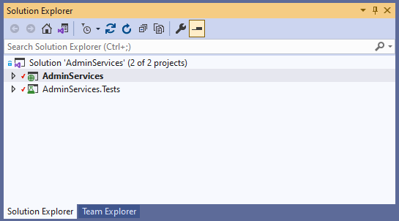

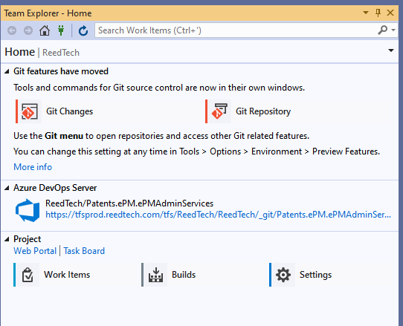

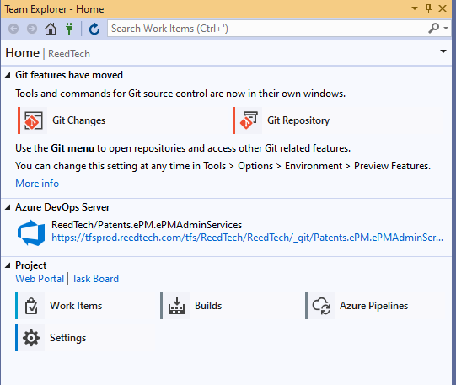

Push

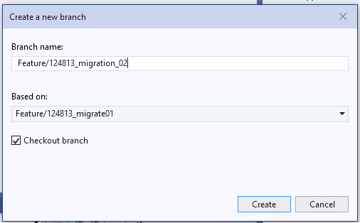

 3. Upgrading & Checking

Friday, August 20, 2021

10:00 AM

**Check References:**

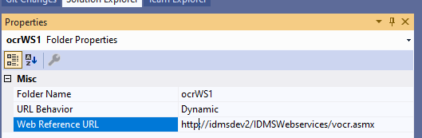

**Modified web references first:**

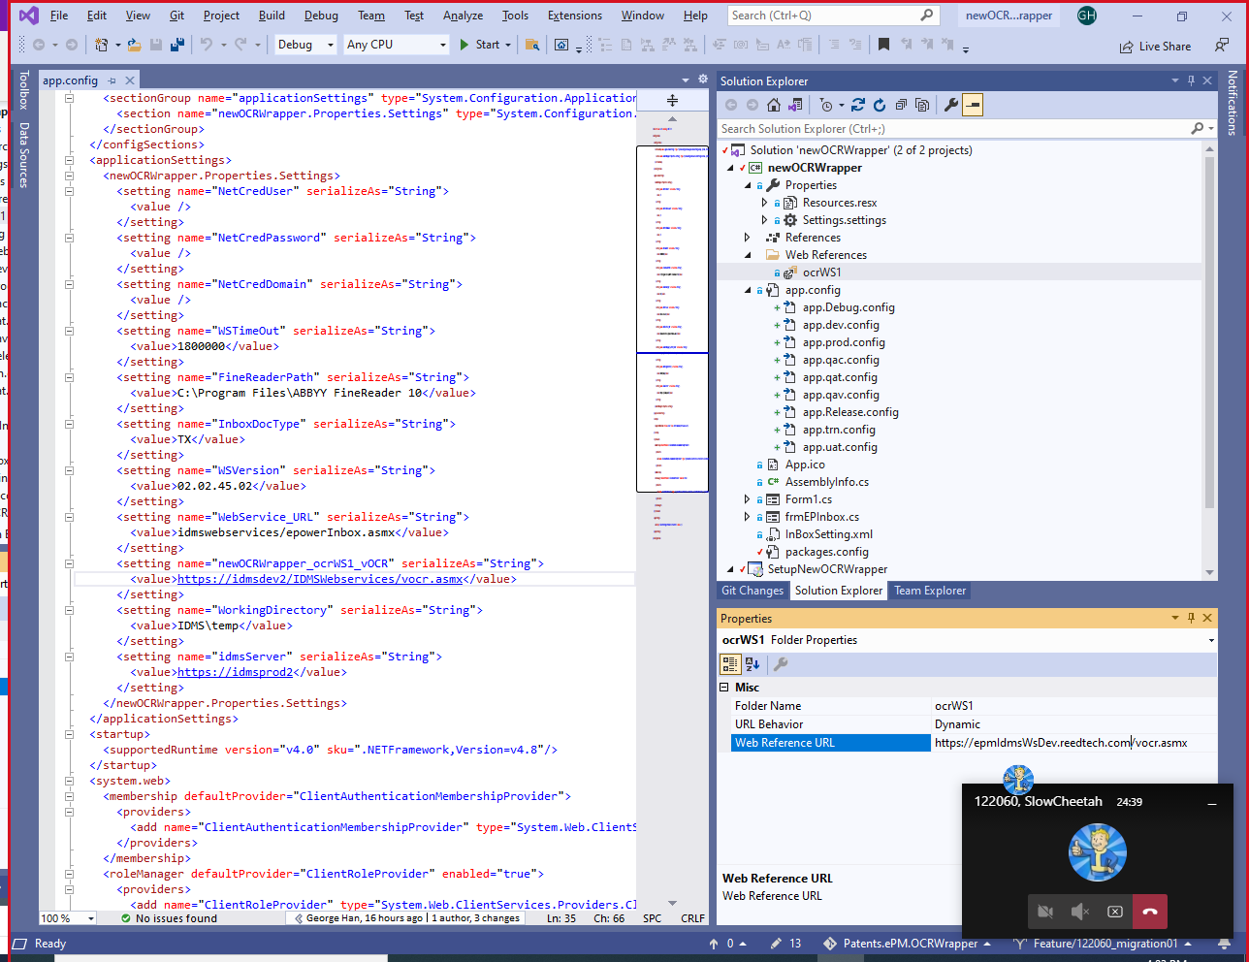

**Items not cared:**

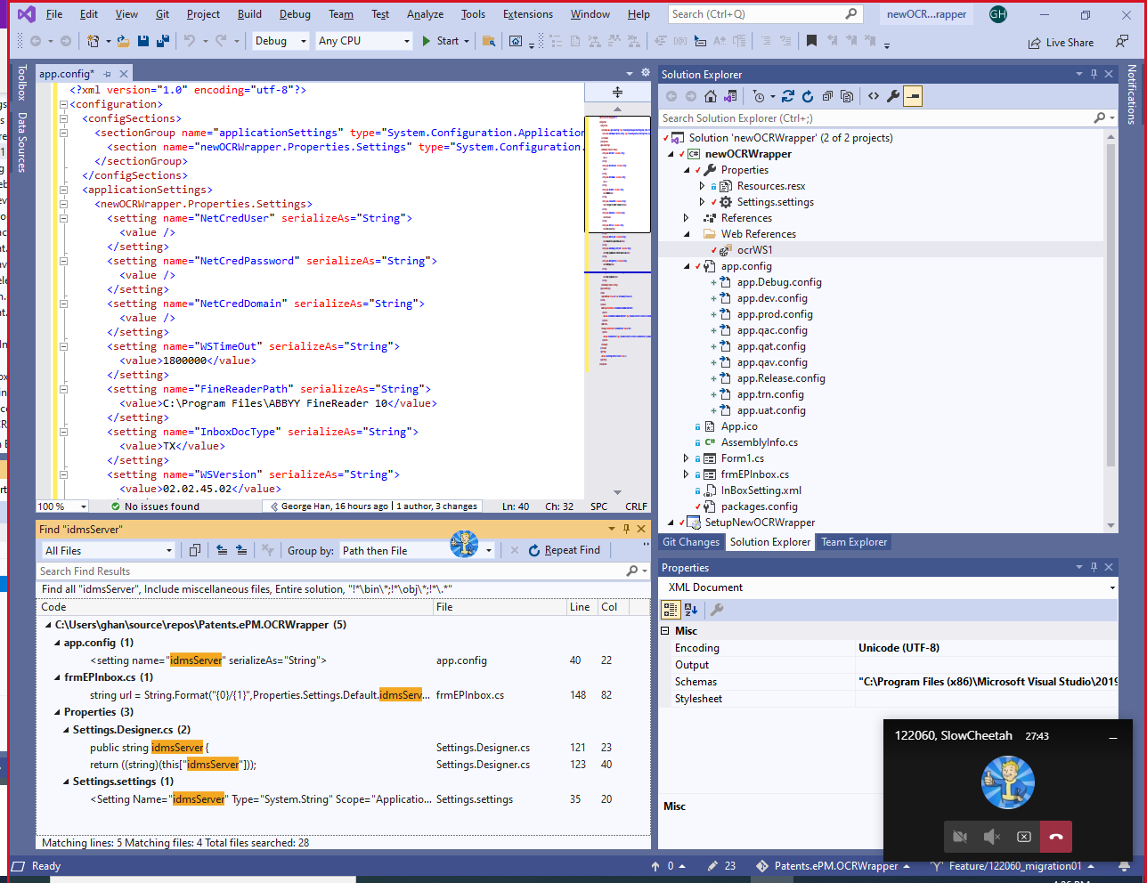

**Modified:**

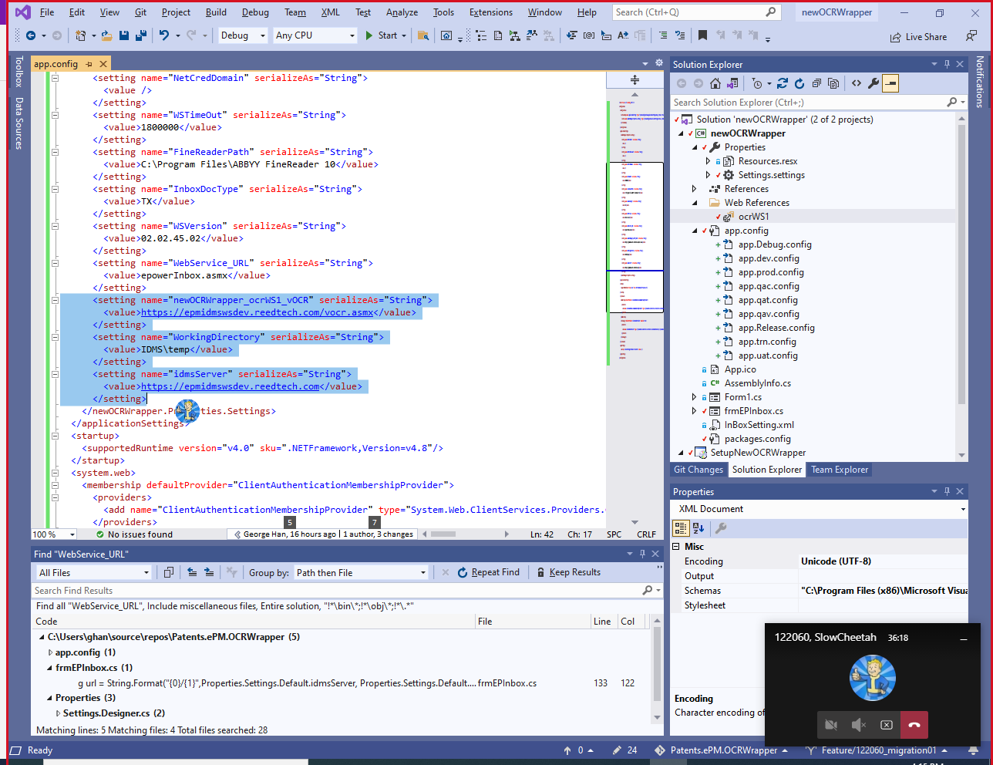

**After: (Get the name from doc.)**

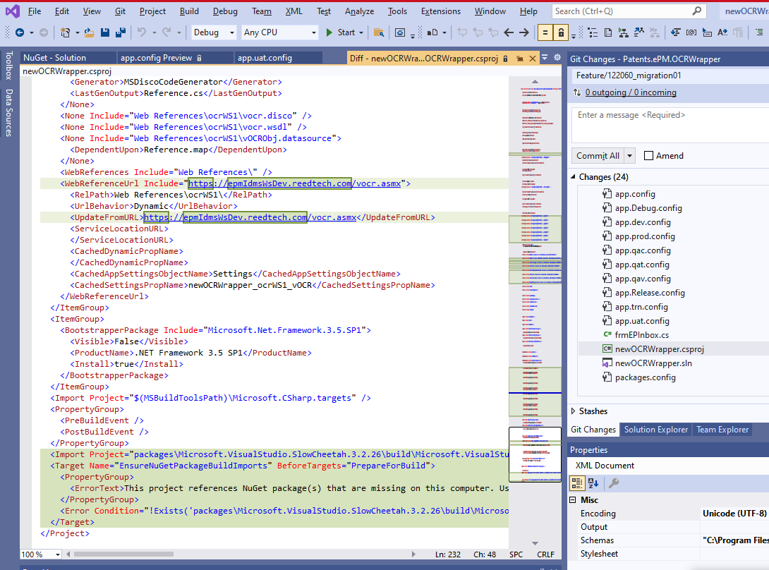

[Tuesday 1:00 PM] Han, Gaogao (LNG-CON)

**http to https?**

Tom, for the issue: from http to https, I remember what you said: This is not a math (means need some personal judgement), but you also mentioned, there are two rule of thumb:

1, Visual Studio created file, will be ignore;

2, The company service, must be paid attention.

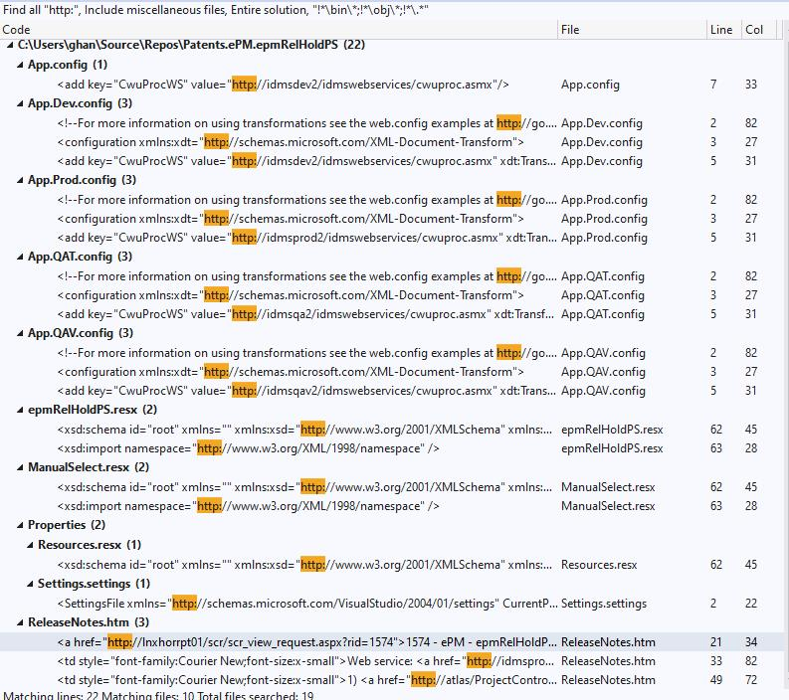

Now, I have a case, 125148, as an example:

.resx file: ignore

releaseNotes.htm could be inogore

I wondeer the ones in .config file, such as

<http://idmsdev2/idmswebservices/cwuproc.asmx>

Does it matter or not matter?

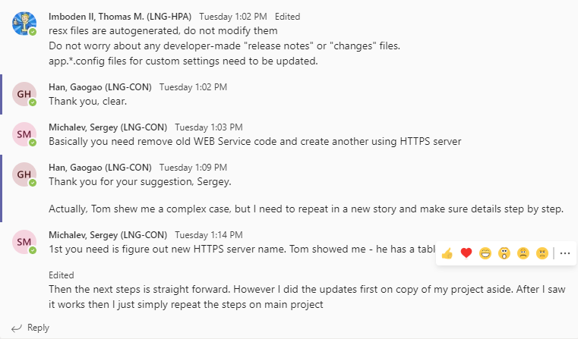

3. Upgrading & Checking

Friday, August 20, 2021

10:00 AM

**Check References:**



**Modified web references first:**



**Items not cared:**



**Modified:**



**After: (Get the name from doc.)**



[Tuesday 1:00 PM] Han, Gaogao (LNG-CON)

**http to https?**

Tom, for the issue: from http to https, I remember what you said: This is not a math (means need some personal judgement), but you also mentioned, there are two rule of thumb:

1, Visual Studio created file, will be ignore;

2, The company service, must be paid attention.



Now, I have a case, 125148, as an example:

.resx file: ignore

releaseNotes.htm could be inogore

I wondeer the ones in .config file, such as

<http://idmsdev2/idmswebservices/cwuproc.asmx>

Does it matter or not matter?



4, SlowCheetah

Friday, August 6, 2021

2:35 PM

[**Creating multiple Build Configurations for client applications**](https://tfsprod.reedtech.com/tfs/ReedTech/ReedTech/_wiki/wikis/ReedTech.wiki/148/Creating-multiple-Build-Configurations-for-client-applications)

[**ScFilesToTransform Item Does Not Define Link**](https://tfsprod.reedtech.com/tfs/ReedTech/ReedTech/_wiki/wikis/ReedTech.wiki/261/ScFilesToTransform-Item-Does-Not-Define-Link)

[SlowCheetah](https://marketplace.visualstudio.com/items?itemName=vscps.SlowCheetah-XMLTransforms) MS

[**How to: Create and edit configurations - Visual Studio**](https://docs.microsoft.com/en-us/visualstudio/ide/how-to-create-and-edit-configurations)

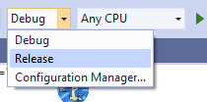

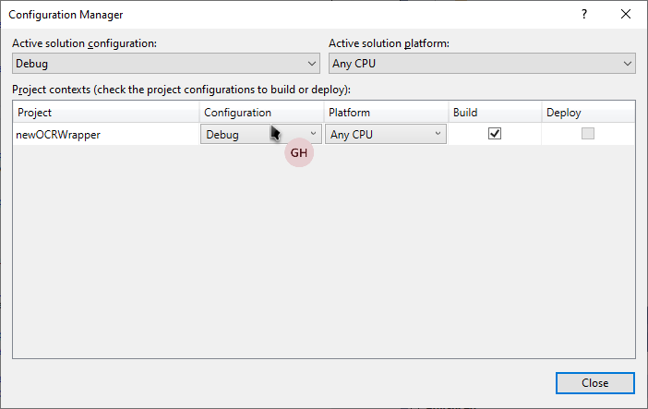

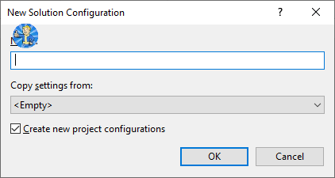

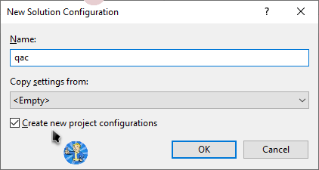

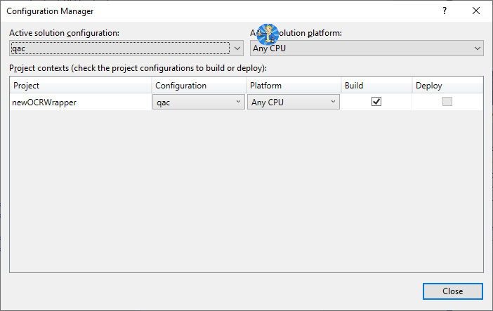

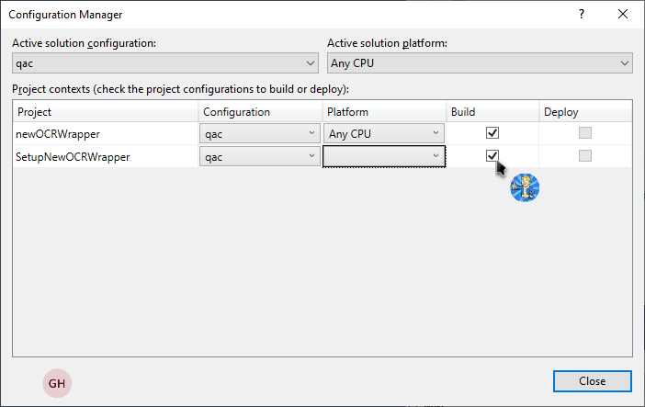

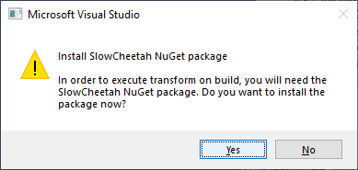

**App.config**

**Environment specific**

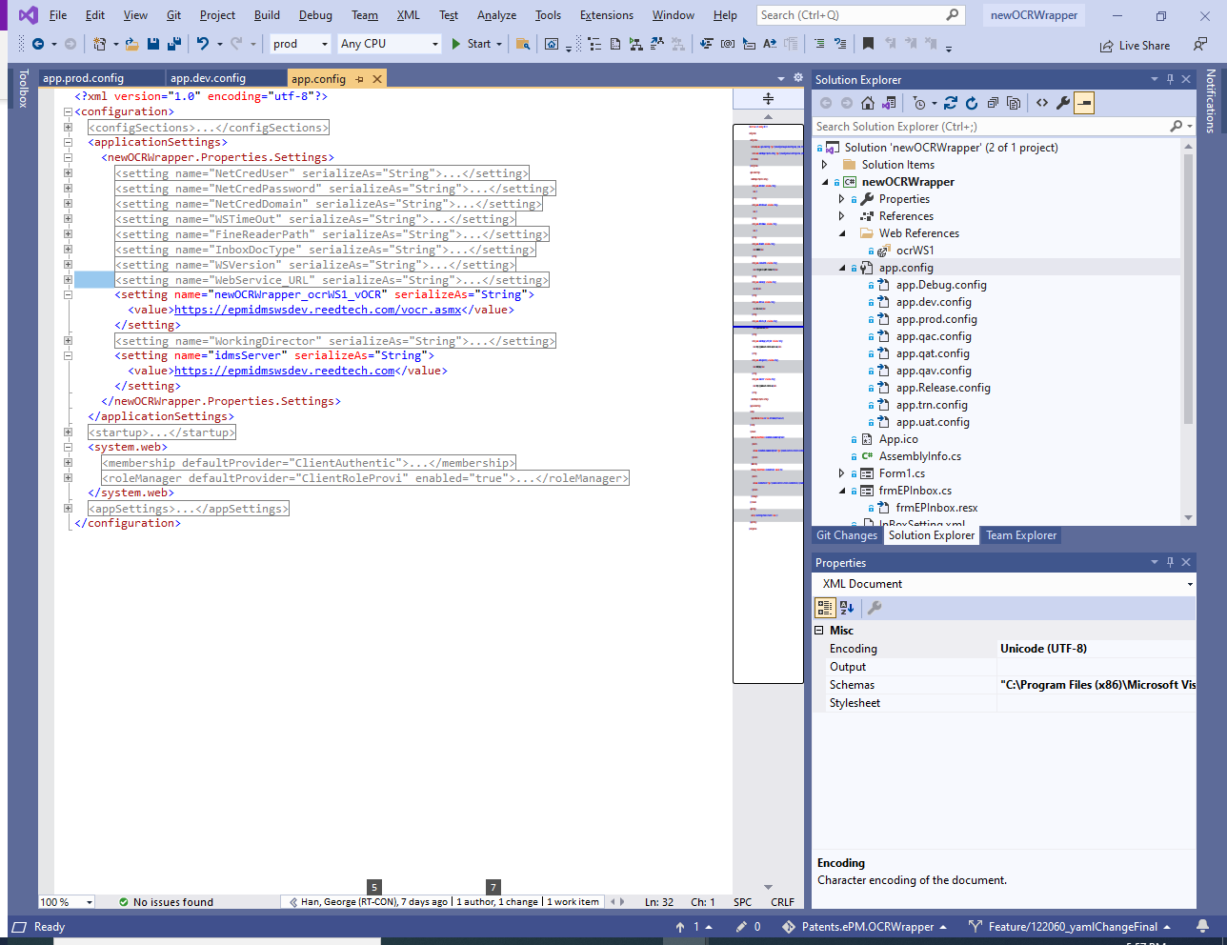

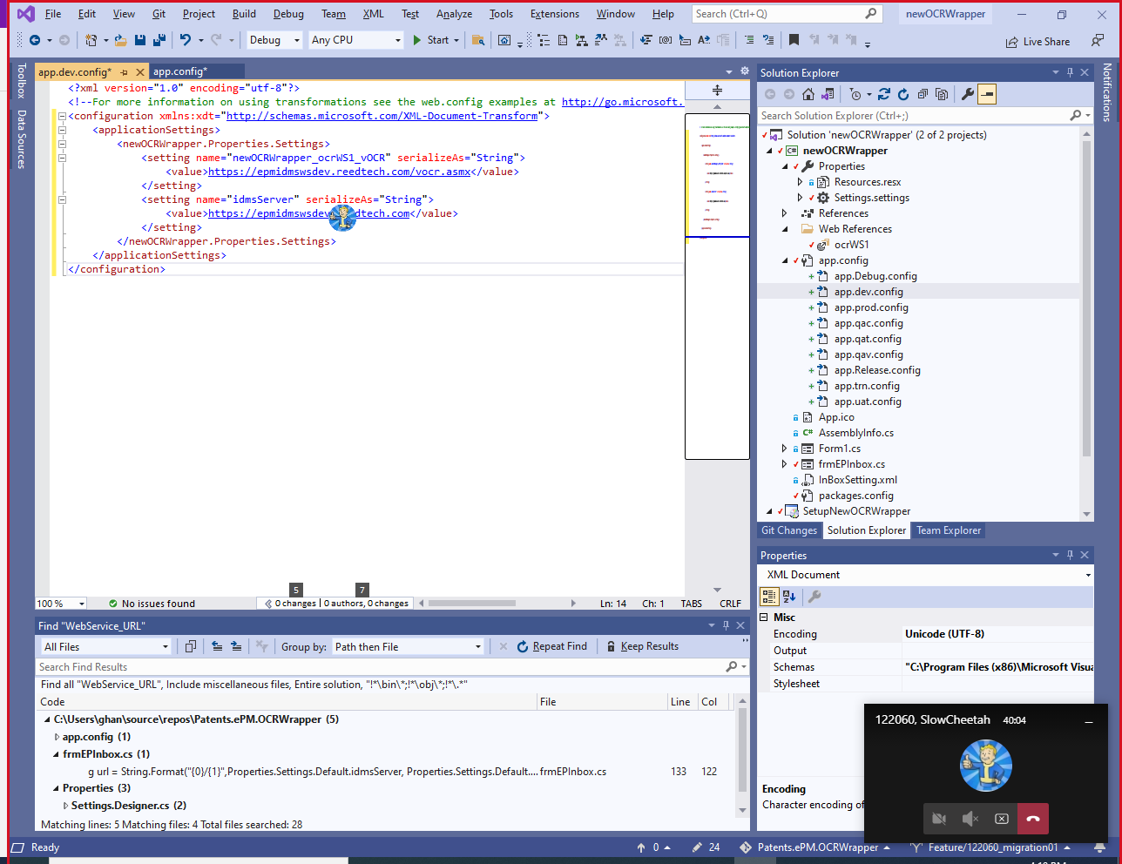

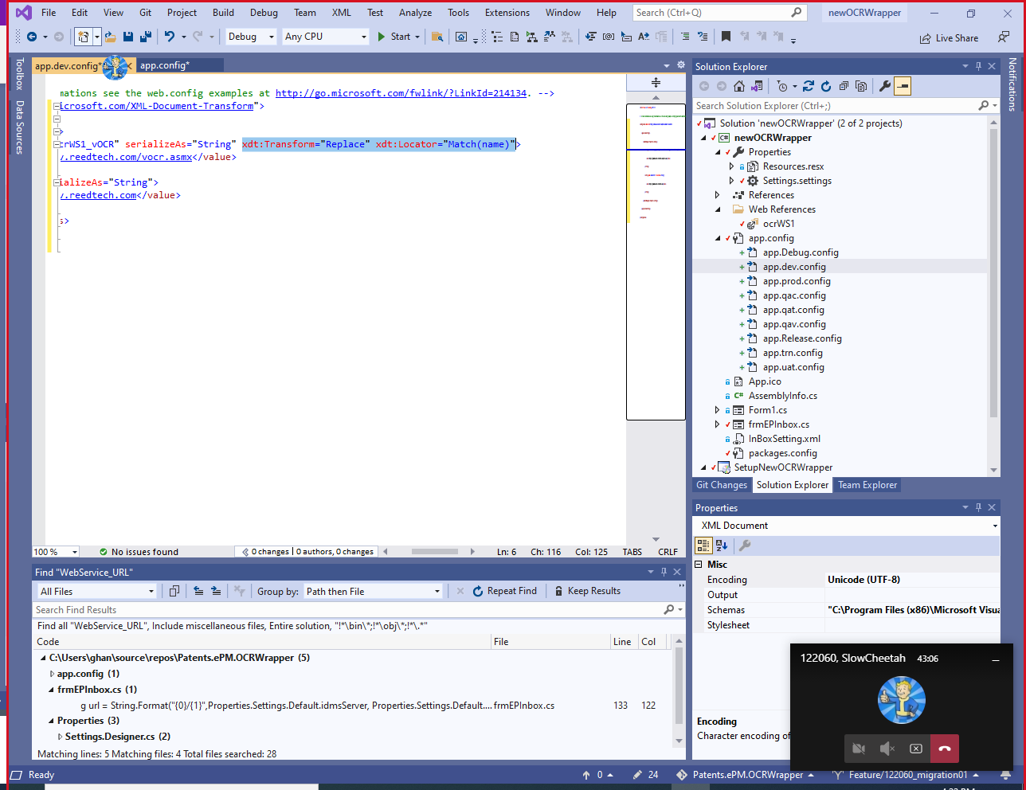

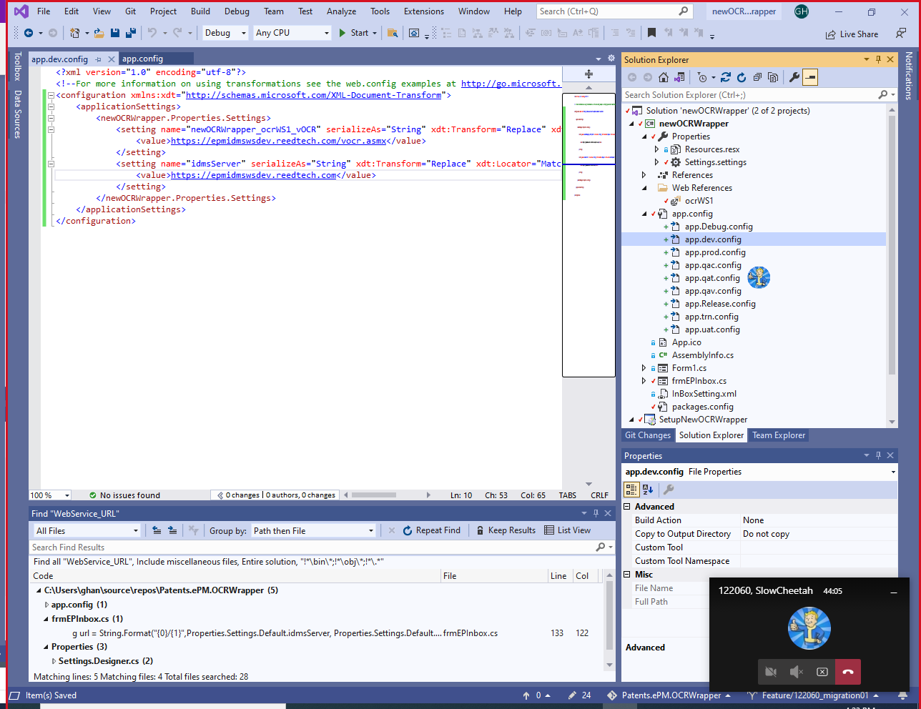

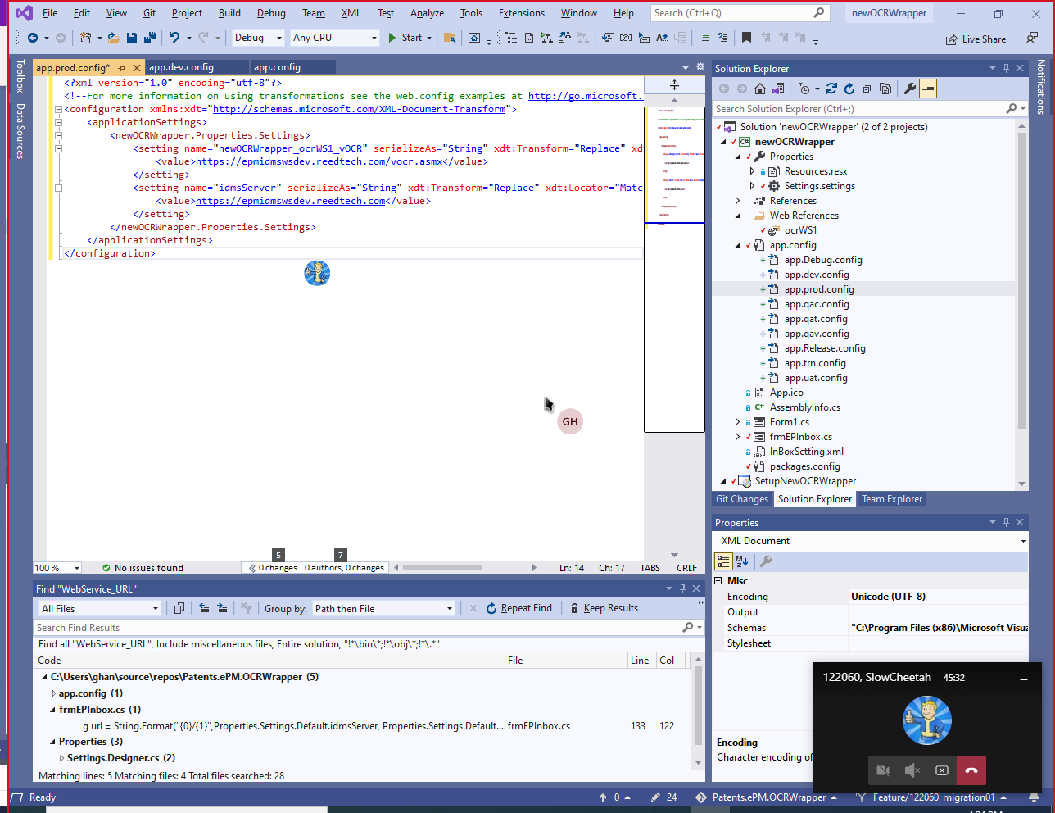

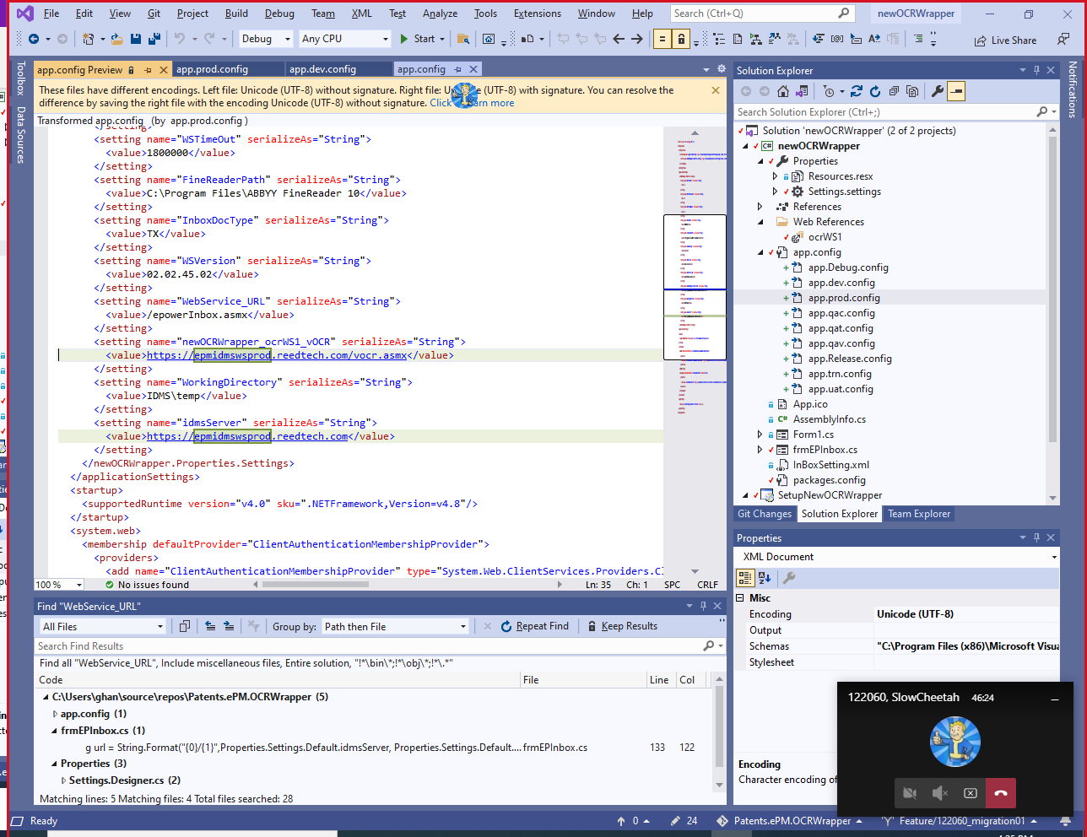

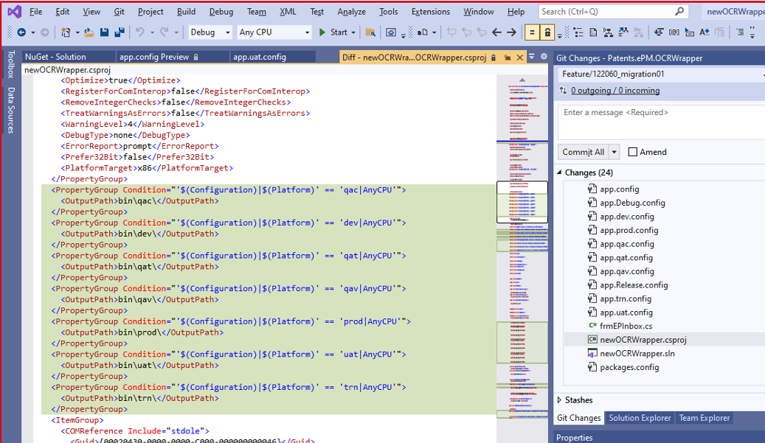

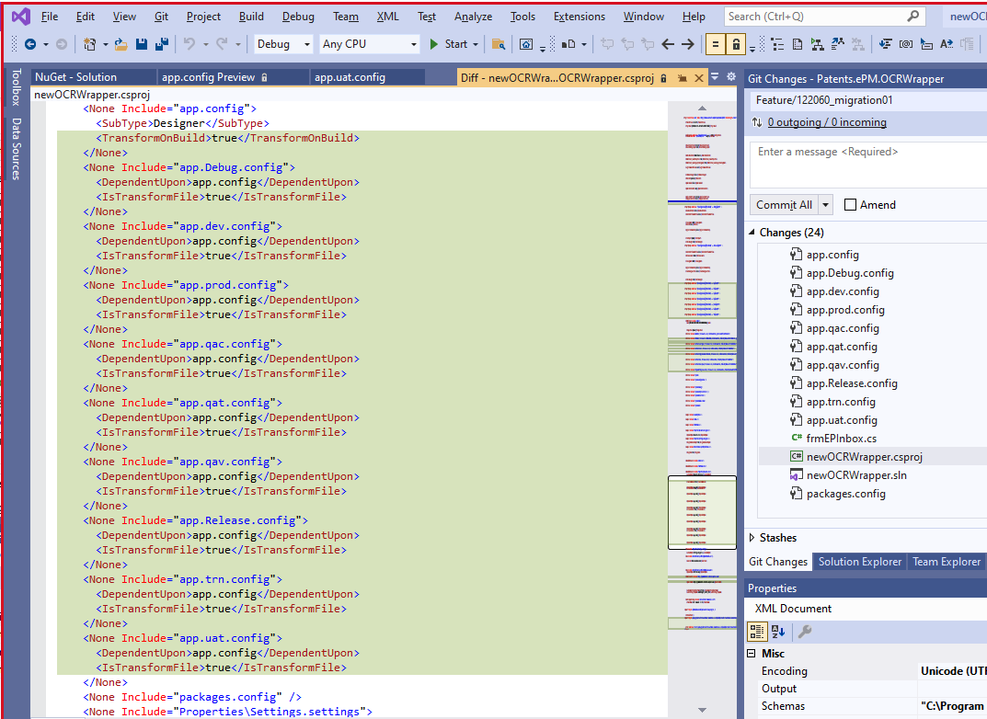

<?xml version="1.0" encoding="utf-8"?>

<!--For more information on using transformations see the web.config examples at <http://go.microsoft.com/fwlink/?LinkId=214134>. -->

<configuration xmlns:xdt="http://schemas.microsoft.com/XML-Document-Transform">

<appSettings>

<add key="EmailTo" value="RTIS-PatentsQA@reedtech.com" xdt:Transform="SetAttributes" xdt:Locator="Match(key)"/>

<add key="UnHoldEmailTo" value="RTIS-PatentsQA@reedtech.com" xdt:Transform="SetAttributes" xdt:Locator="Match(key)"/>

<add key="EmailCC" value="RTIS-PatentsQA@reedtech.com" xdt:Transform="SetAttributes" xdt:Locator="Match(key)"/>

<add key="Archive" value="\\porcia\idmsdev\Omaha_Staging\pto_export\grant\reports\" xdt:Transform="SetAttributes" xdt:Locator="Match(key)"/>

<add key="RTFMLoader.RTFMLoadProxy.RtfmLoad" value="https://epmRtfmWsDev.reedtech.com/RtfmLoad.asmx" xdt:Transform="SetAttributes" xdt:Locator="Match(key)" />

</appSettings>

<applicationSettings>

<RTFMLoader.Properties.Settings>

<setting name="RTFMLoader_RTFMLoadProxy_RtfmLoad" serializeAs="String" xdt:Transform="Replace" xdt:Locator="Match(name)">

<value>https://epmrtfmwsdev.reedtech.com/RtfmLoad.asmx</value>

</setting>

<setting name="RTFMLoader_email_ws_MailService" serializeAs="String" xdt:Transform="Replace" xdt:Locator="Match(name)">

<value>https://epmmailservicedev.reedtech.com/mailservice.asmx</value>

</setting>

</RTFMLoader.Properties.Settings>

</applicationSettings>

</configuration>

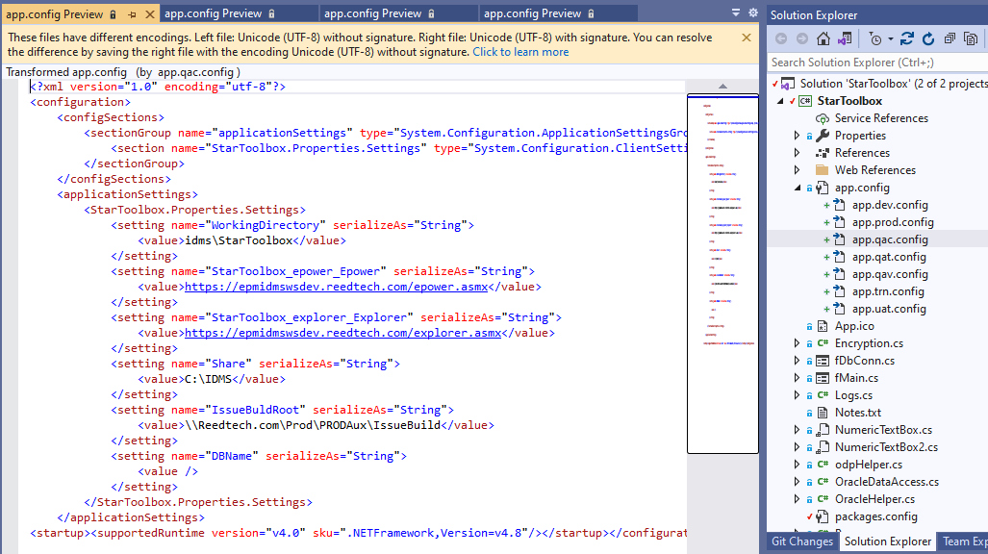

4-1. Create new project

Saturday, August 14, 2021

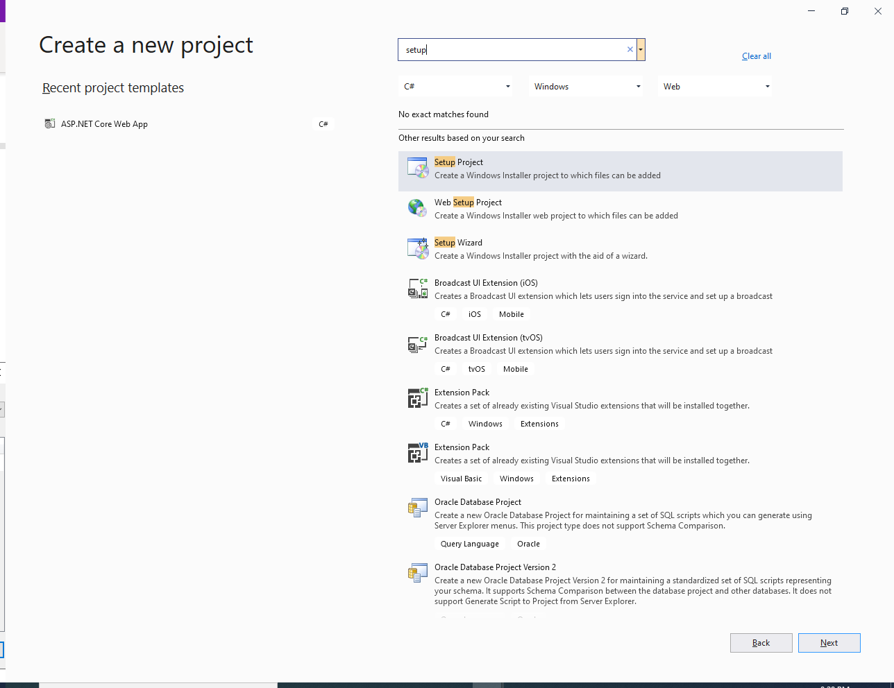

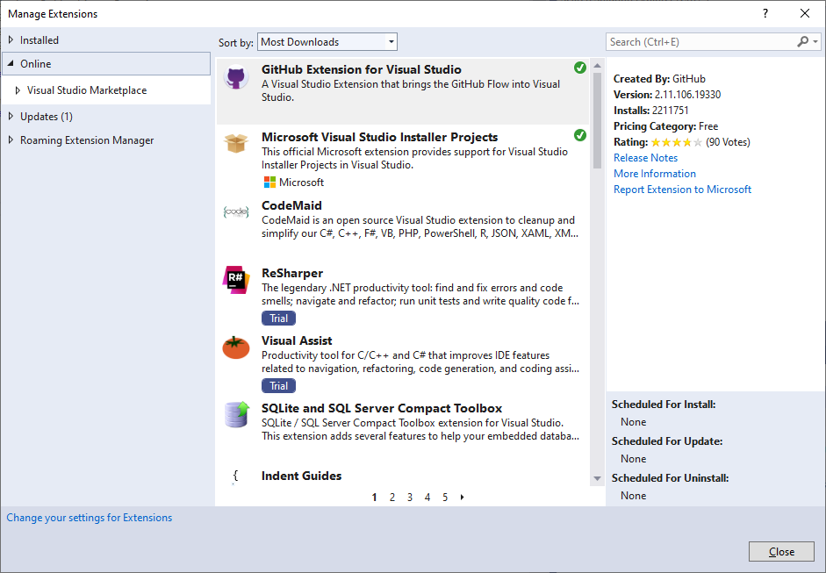

2-3. Push & Pull

Wednesday, July 28, 2021

2:45 PM

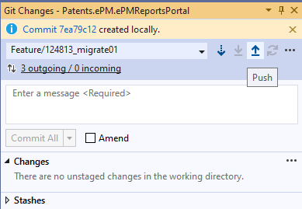

Should get this:

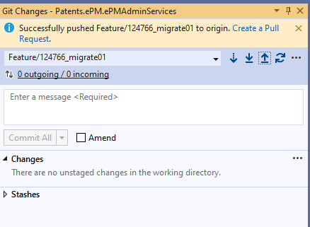

Then **Click Create a Pull.**

**But sometimes, get this:**

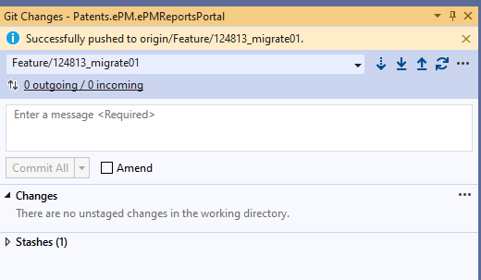

Then go to: pull request page:



Then make a request:

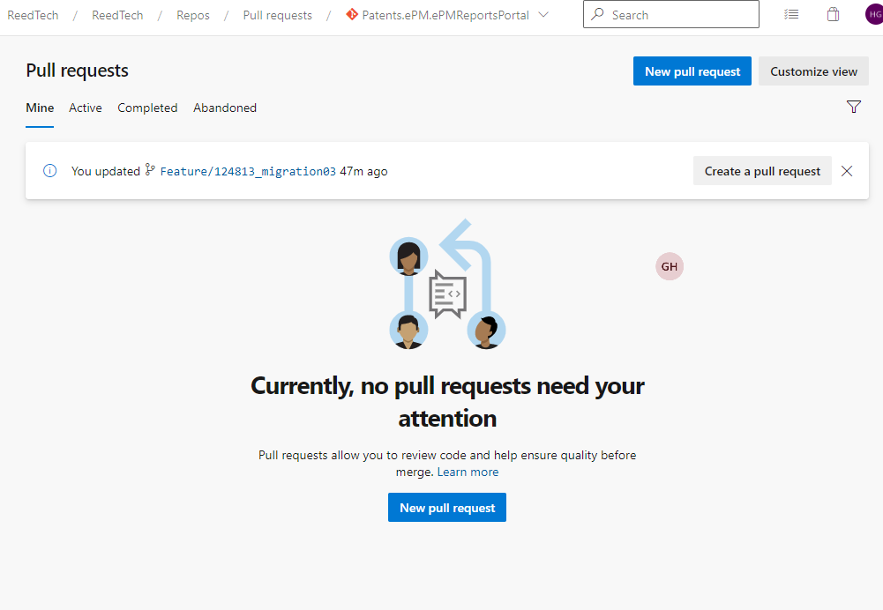

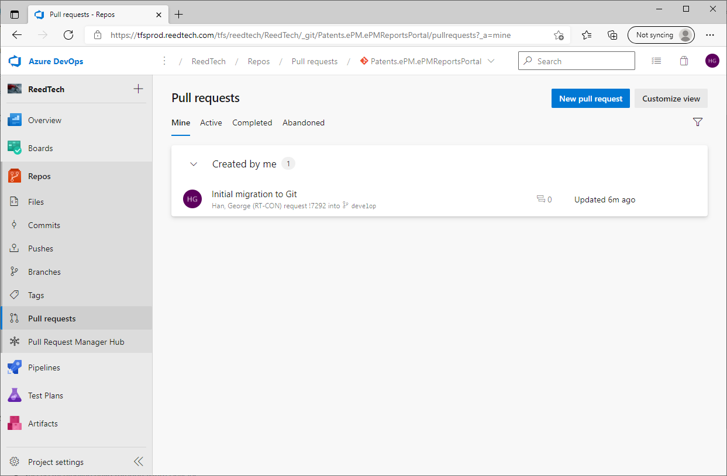

**Click Create a Pull**

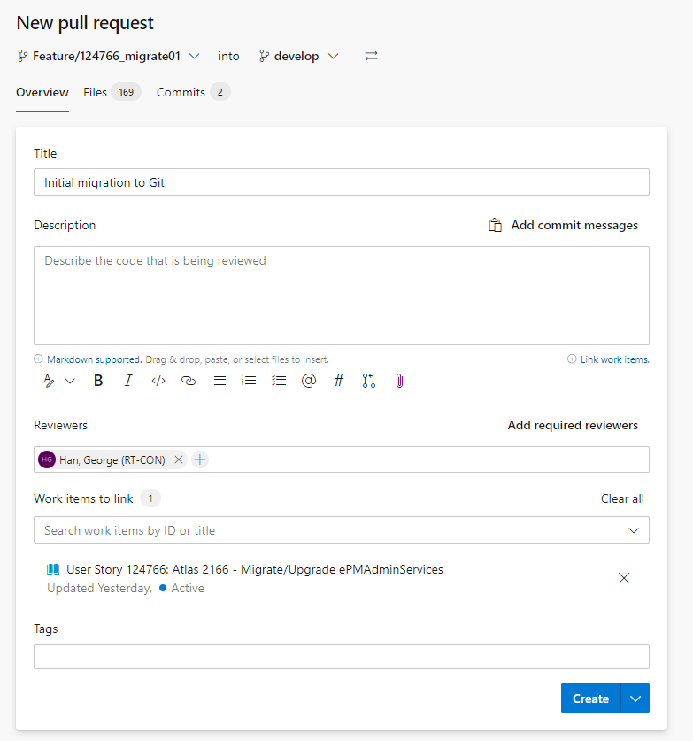

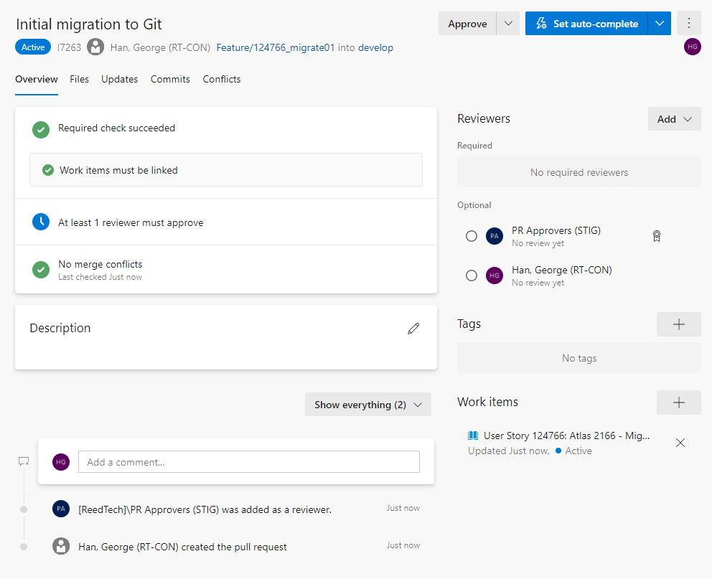

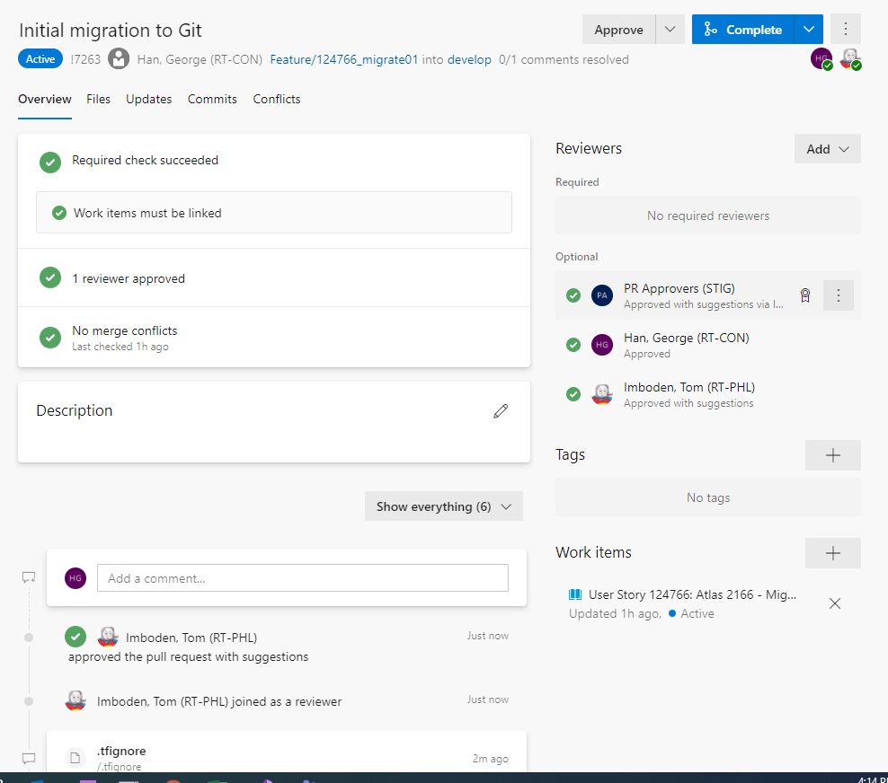

Complete:

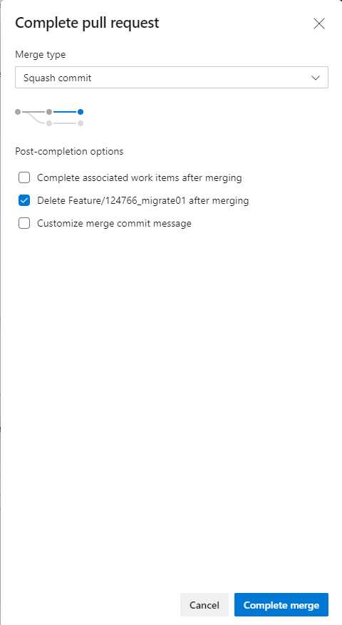

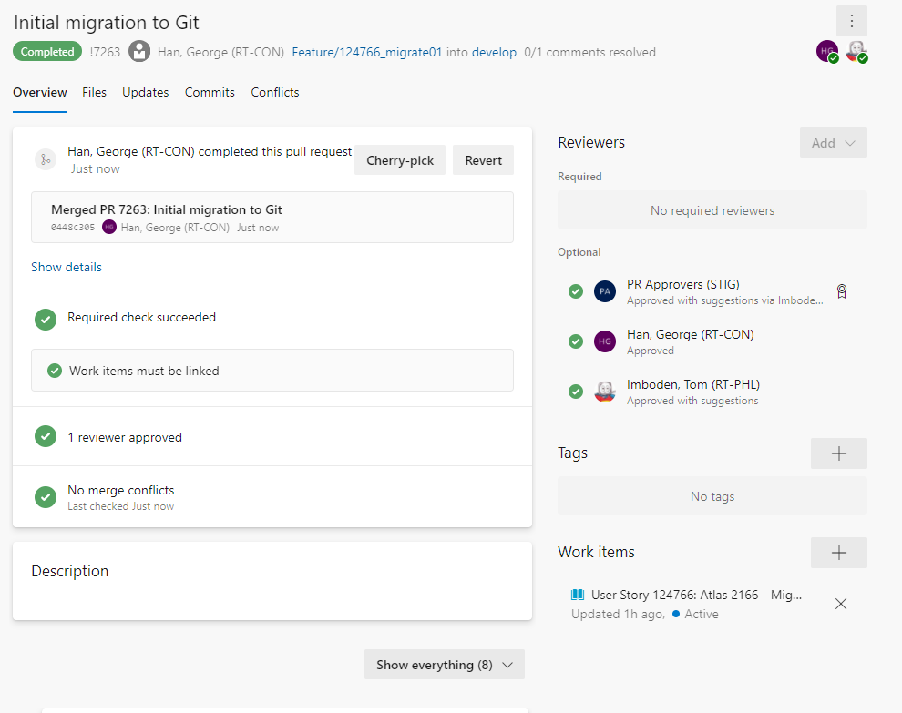

**Second Pull:**

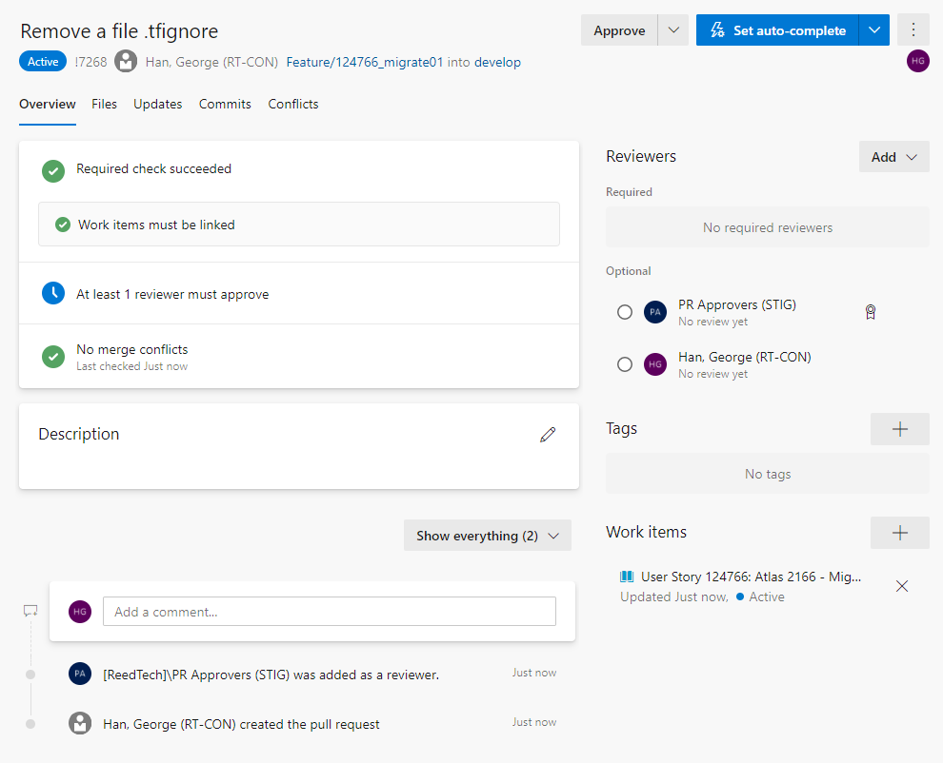

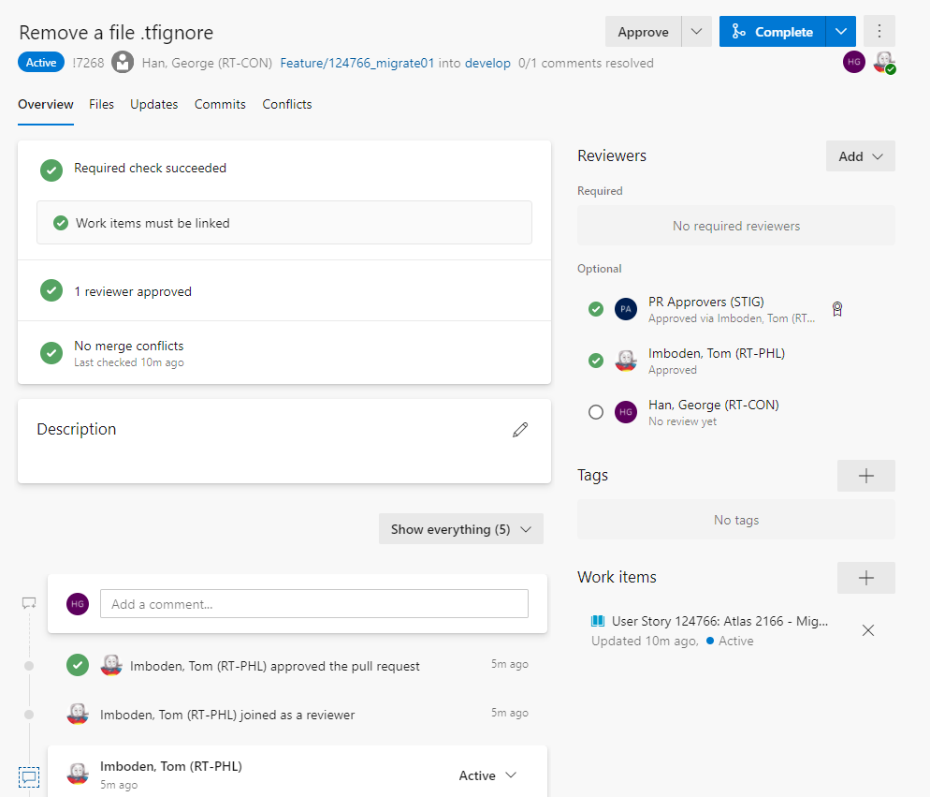

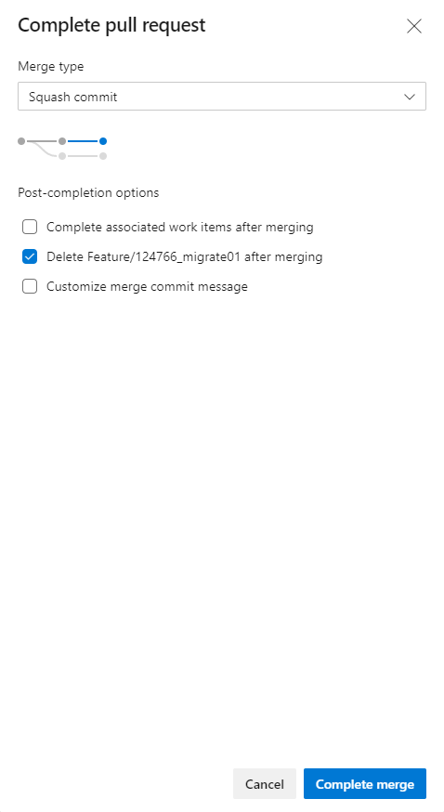

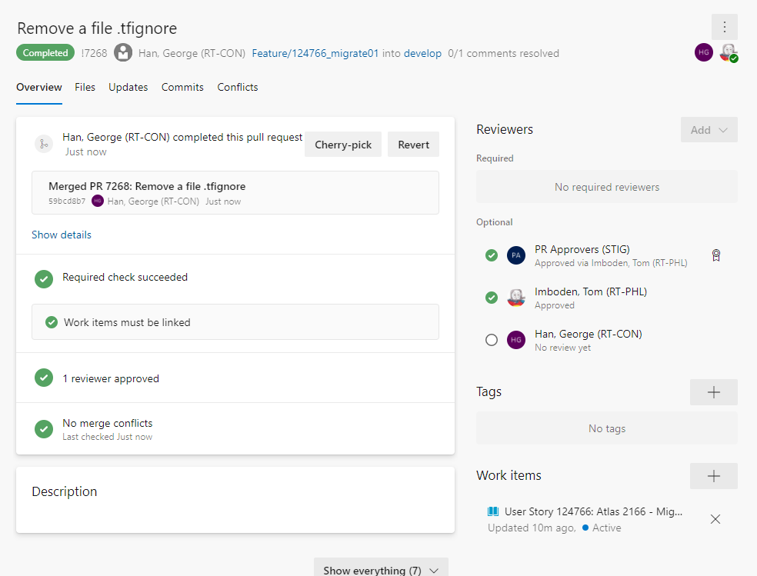

5. Add yaml file

Thursday, July 29, 2021

8:48 PM

**After Migration to Git (after Pull Request is approved)**

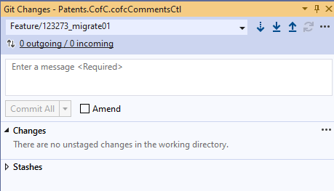

**Change to Develop**

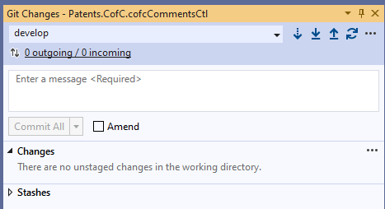

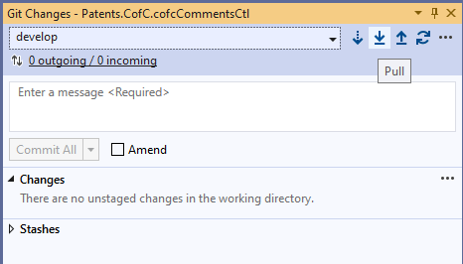

yal

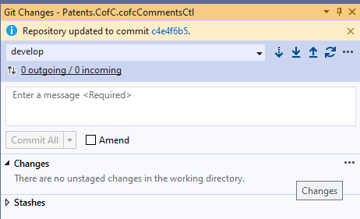

**Create a new branch:**

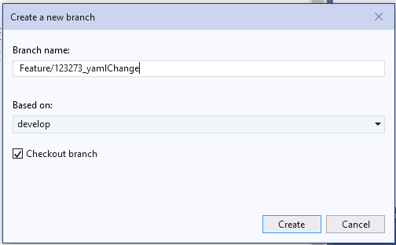

**Could be web service references changed, but not this one:**

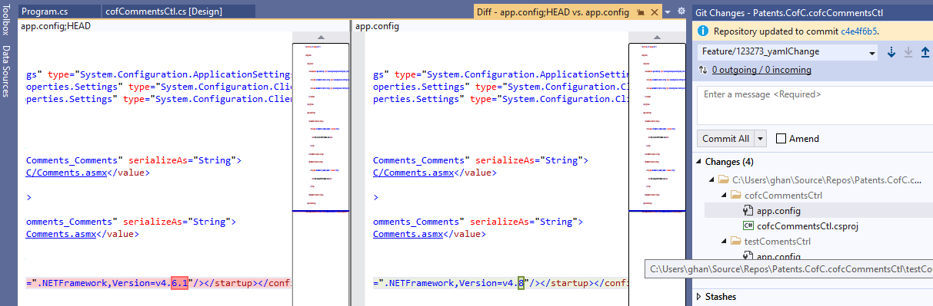

1. Based upon the type of project for which you are creating an Azure DevOps pipeline, [choose the appropriate YAML template](https://tfsprod.reedtech.com/tfs/ReedTech/ReedTech/_git/Patents.DevOps?path=%2FAzureDevOps%2FYAML%2FPipelines%2FSamples&version=GBmaster) from the list of available YAML pipeline samples:

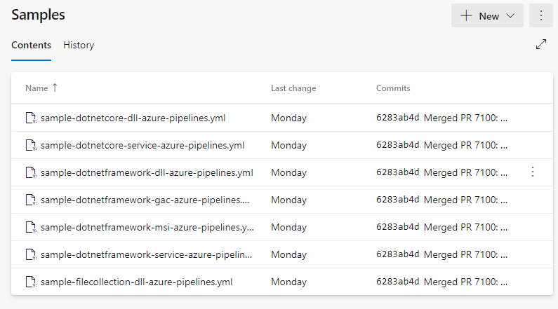

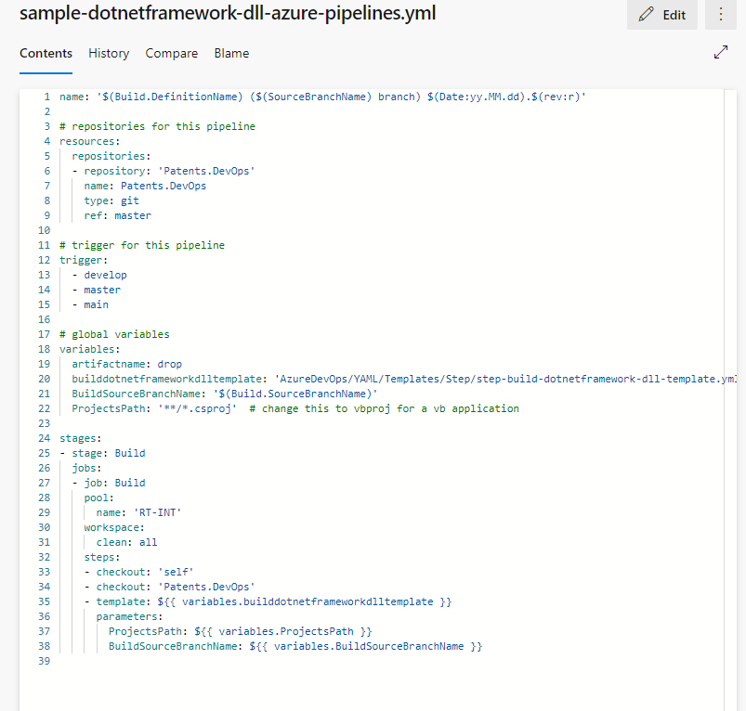

**Download and copy/paste to the working folder:**

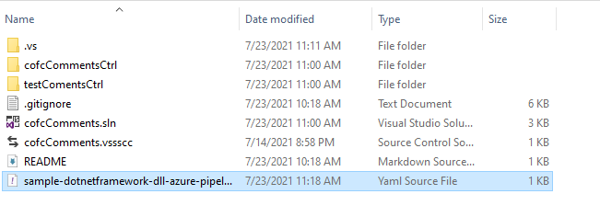

**Change name:**

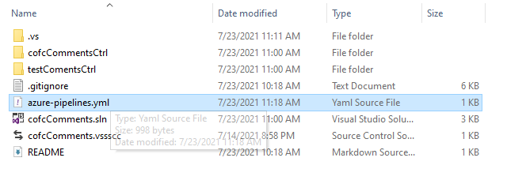

**View:**

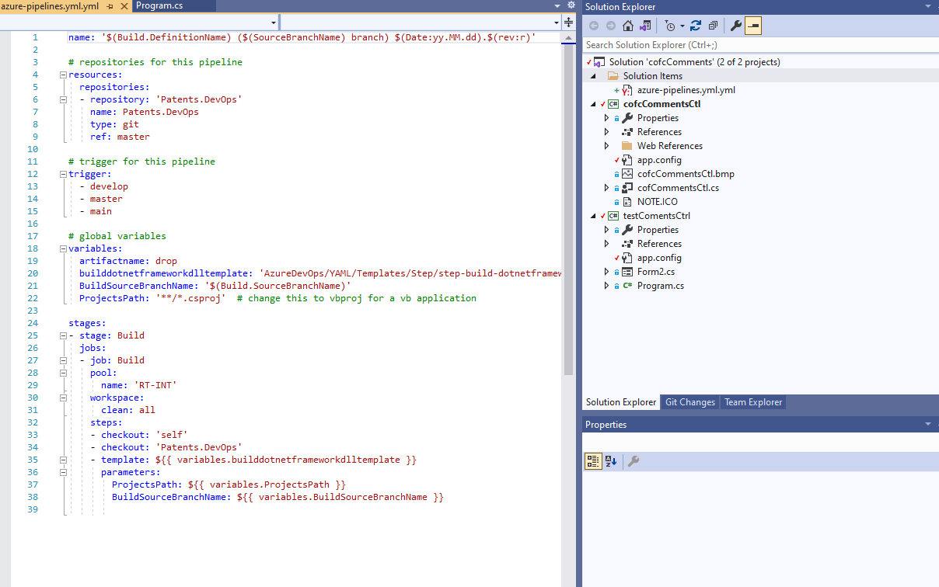

**Add these two files if not exist:**

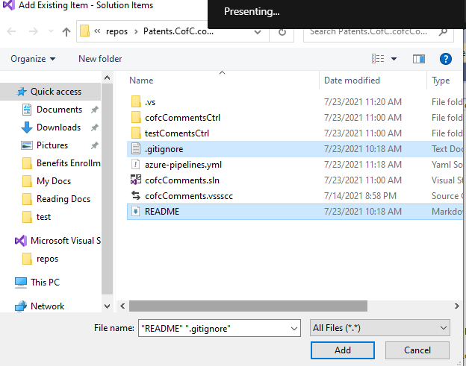

**Repo like this:**

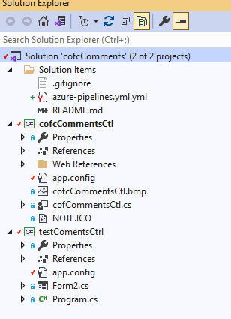

**We don't need the test program build, specifically for dll with test program build**

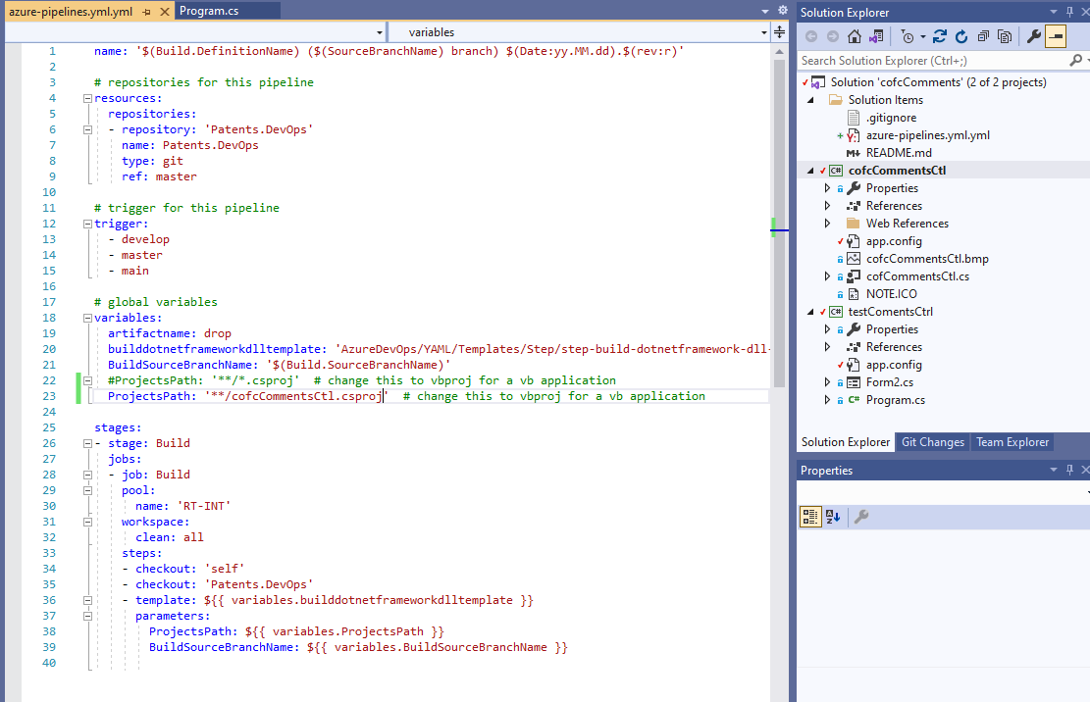

**Commit Staged**

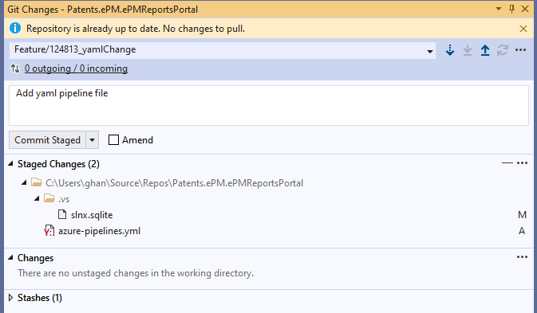

**After committing stage changed**

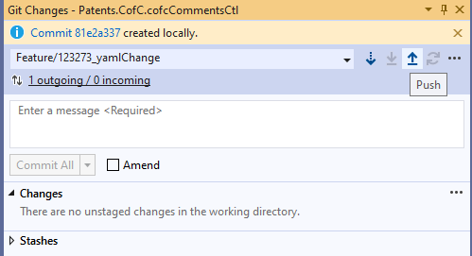

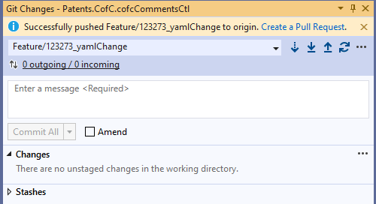

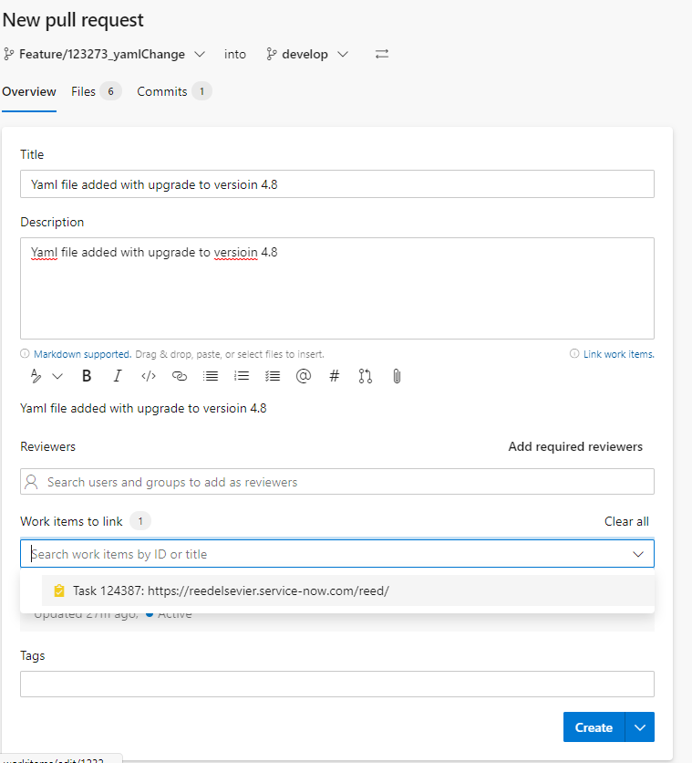

NEW:

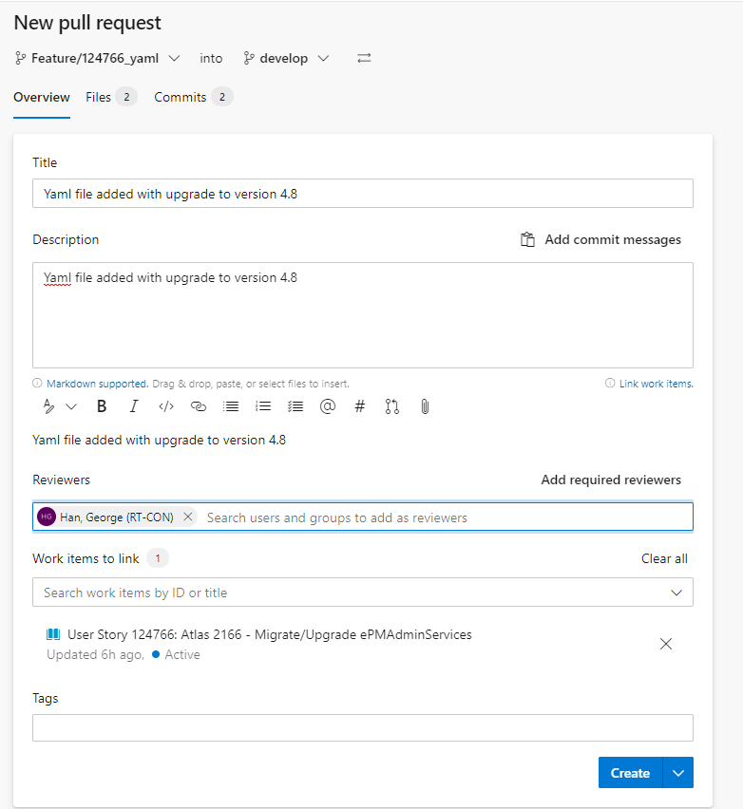

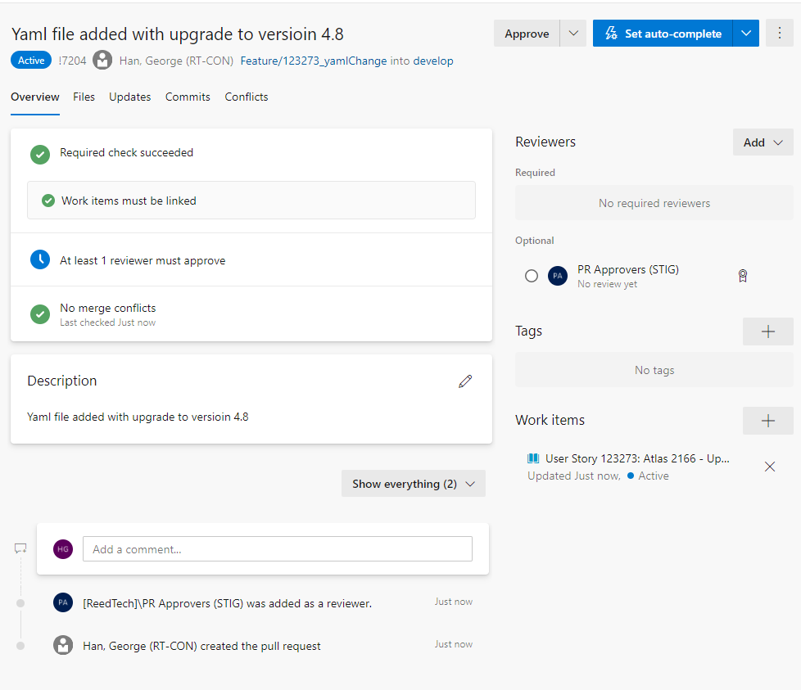

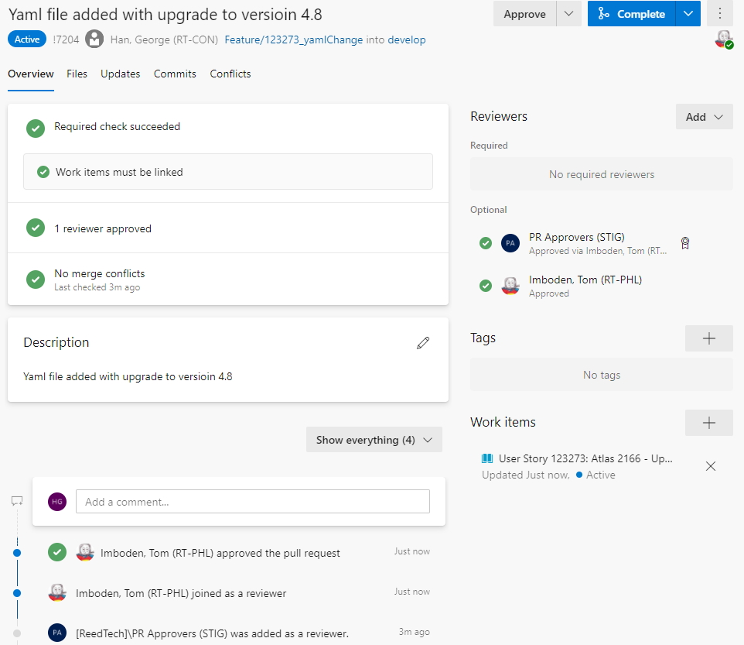

* 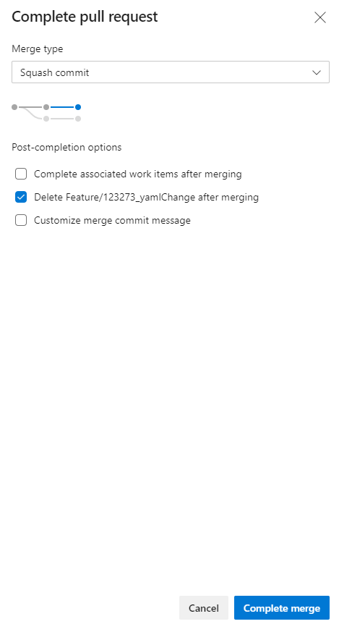

* 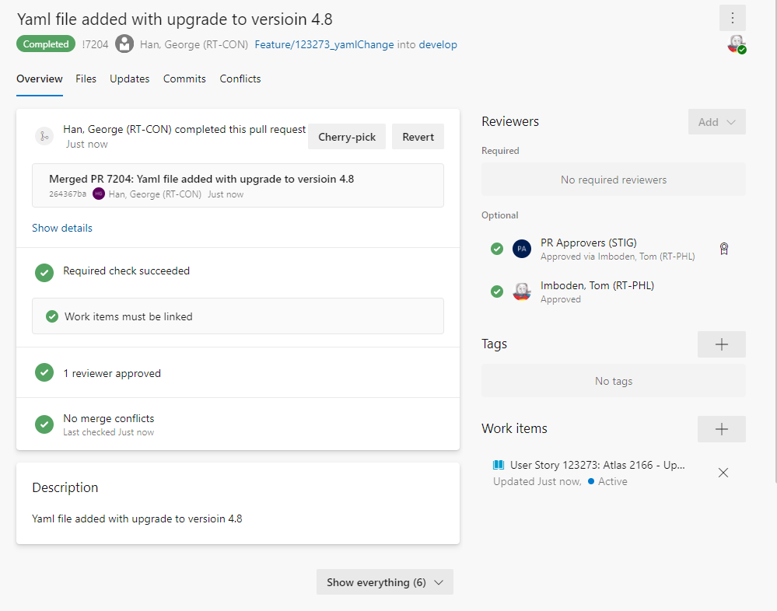

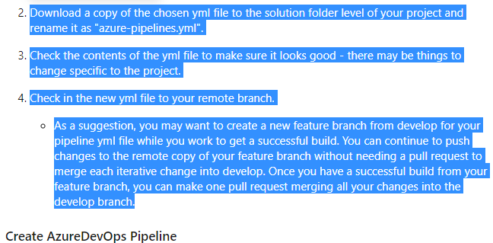

6. Create YAML build pipelines

Thursday, July 29, 2021

9:23 PM

* Create YAML build pipelines

*From <*[*https://tfsprod.reedtech.com/tfs/ReedTech/ReedTech/_boards/board/t/STIG/Stories/?workitem=123273*](https://tfsprod.reedtech.com/tfs/ReedTech/ReedTech/_boards/board/t/STIG/Stories/?workitem=123273)*>*

**1, go to** [**YAML page**](https://tfsprod.reedtech.com/tfs/reedtech/ReedTech/_build?definitionScope=%5CPatents%5CYAML) **at**

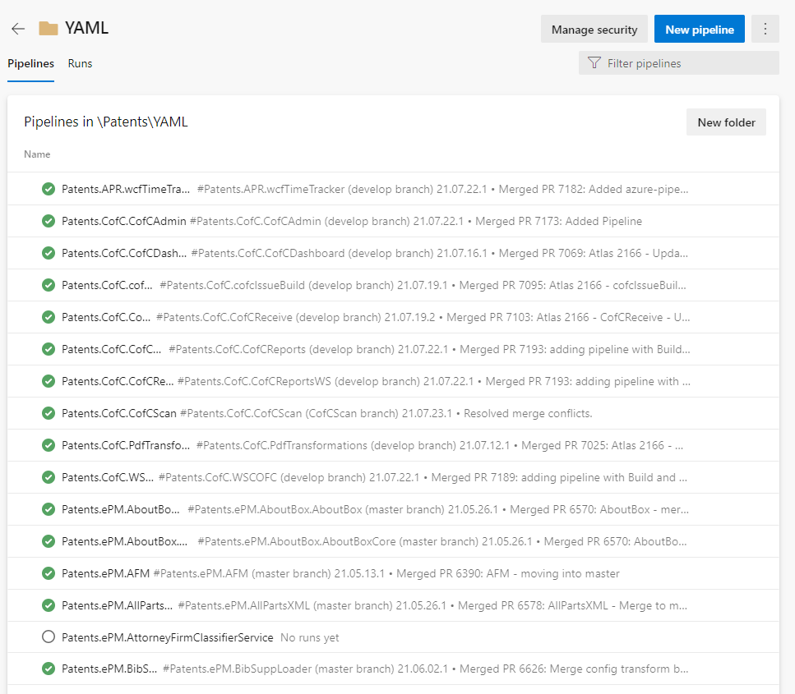

**2, Click New Pipeline**



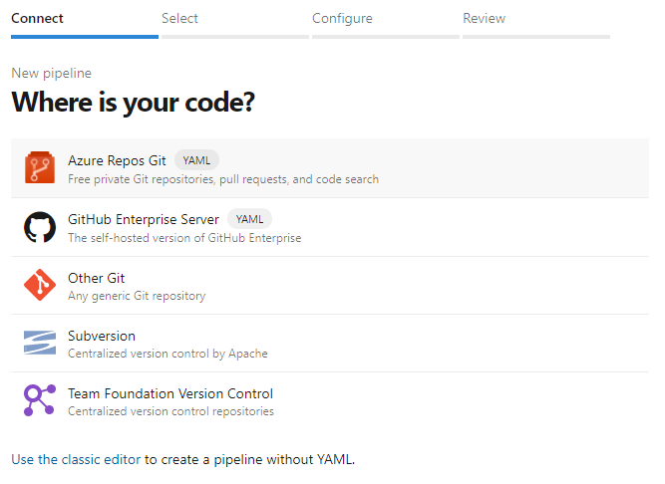

**3, Click**

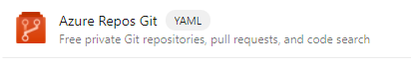

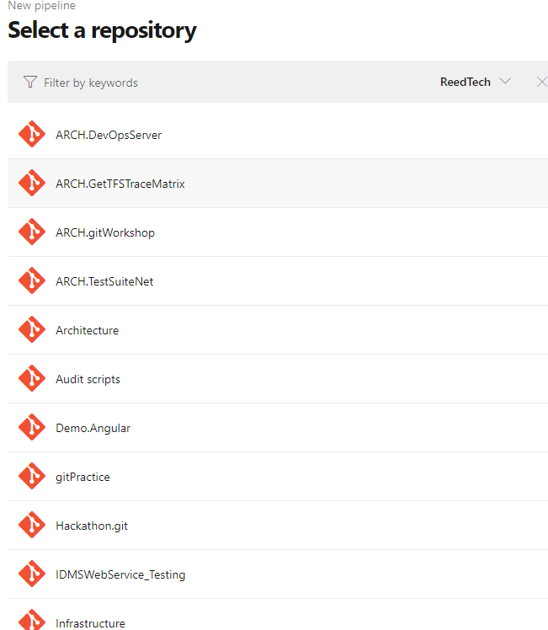

**4, Click your App, such as**

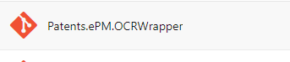

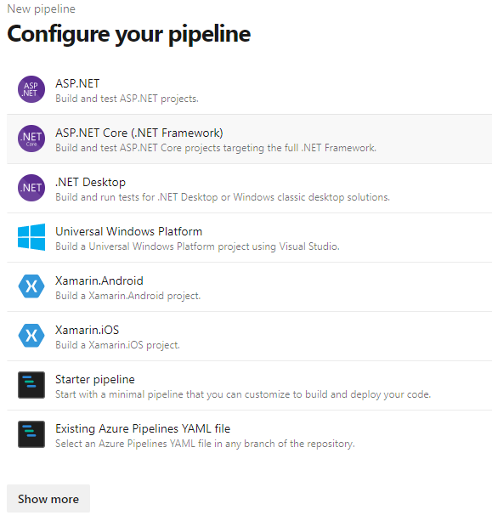

**5, Click**

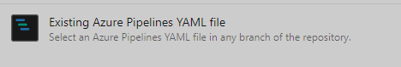

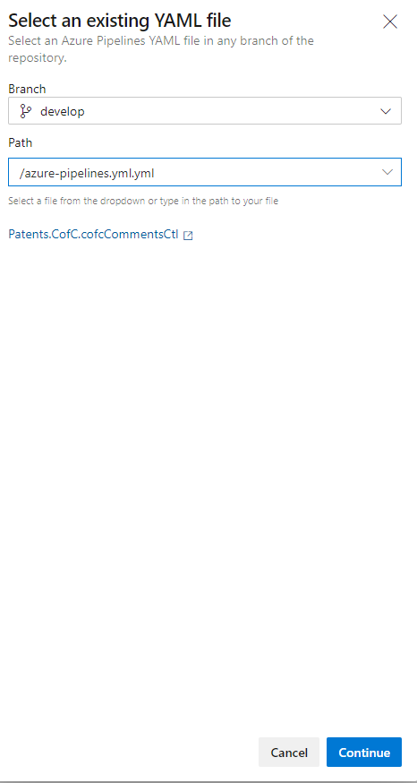

1. **Click Continue**

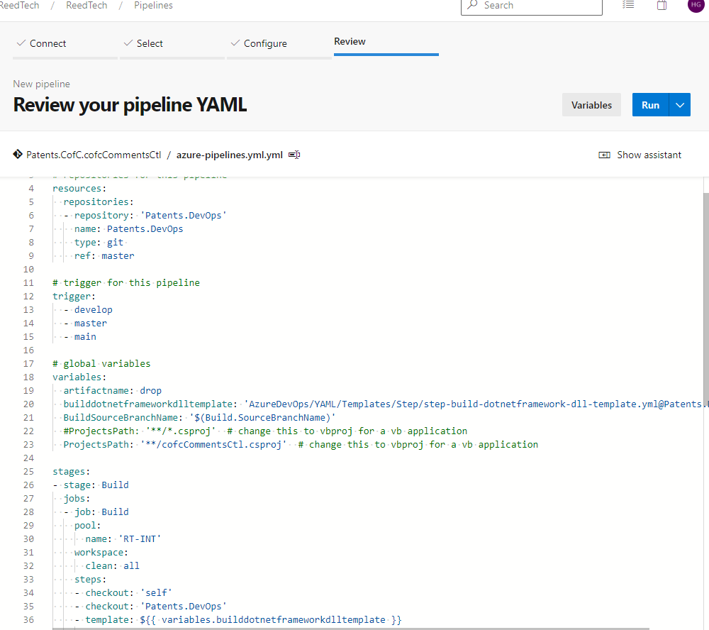

1. **Run:**

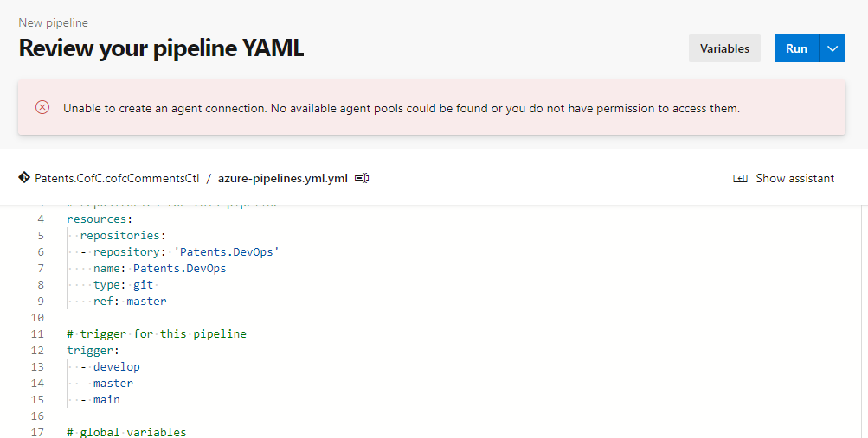

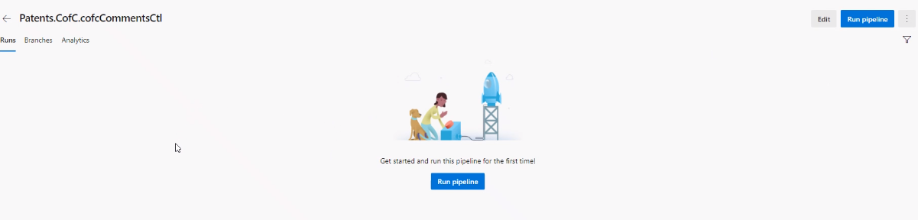

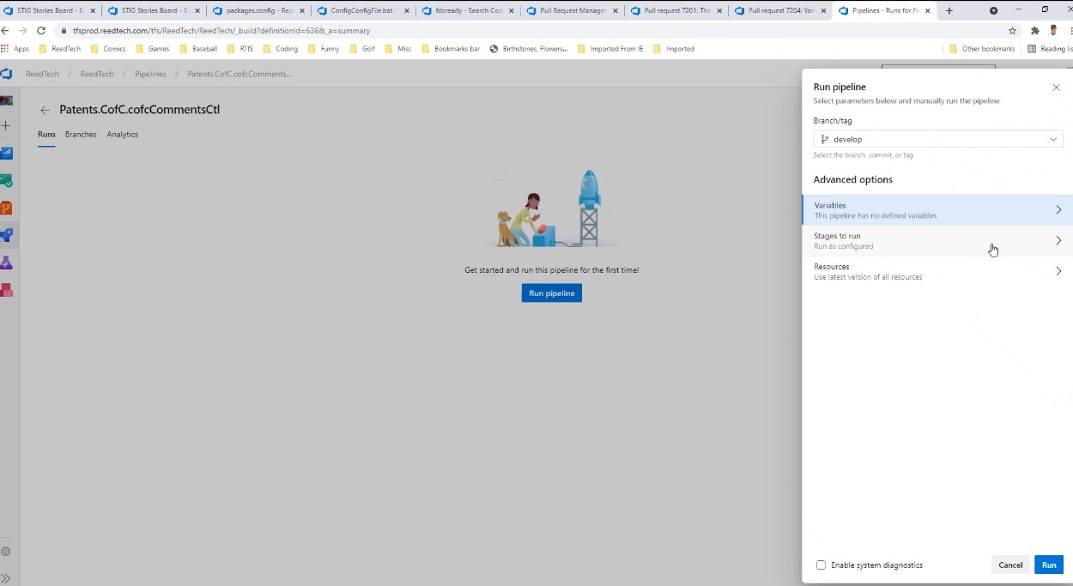

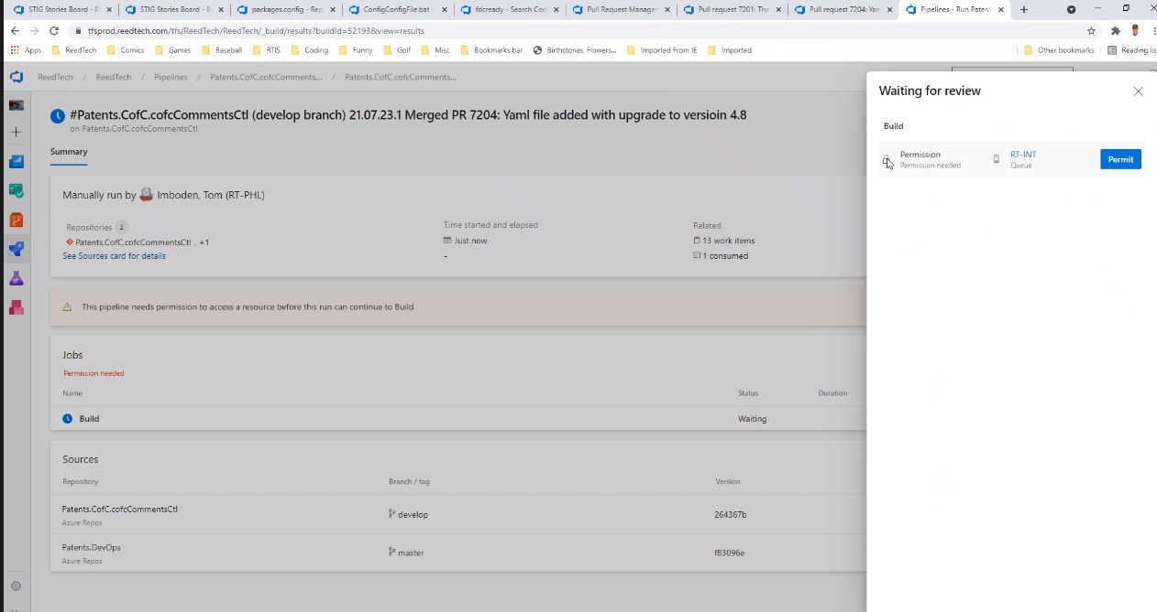

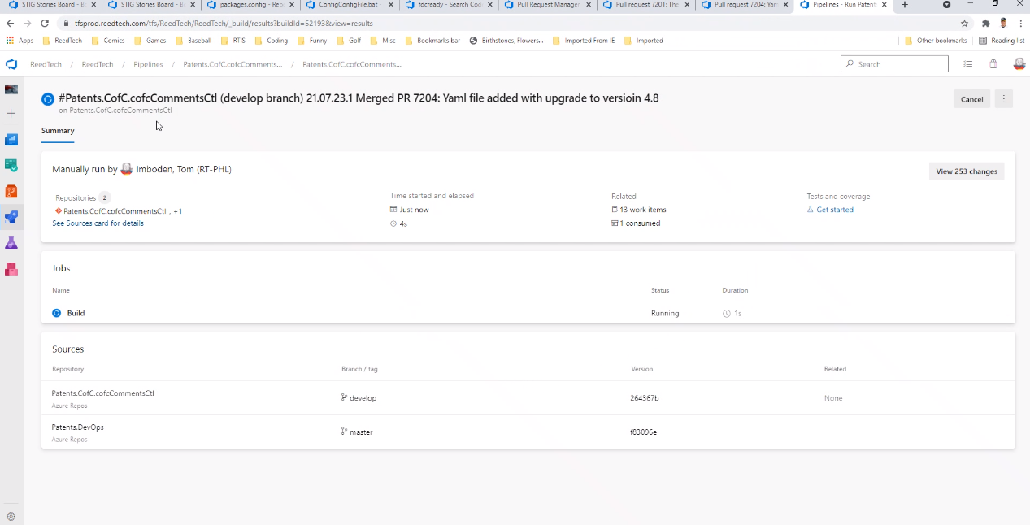

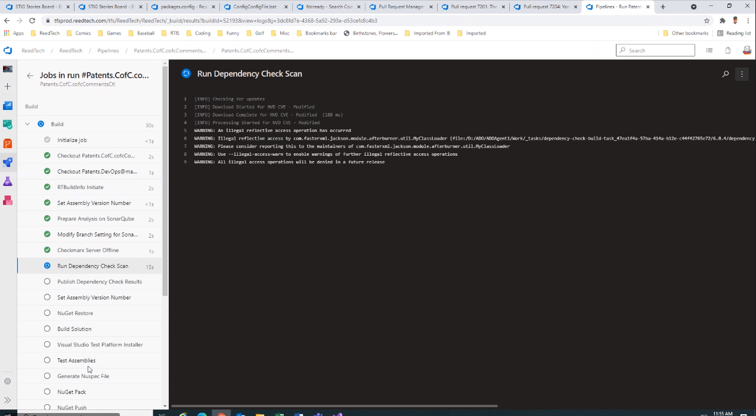

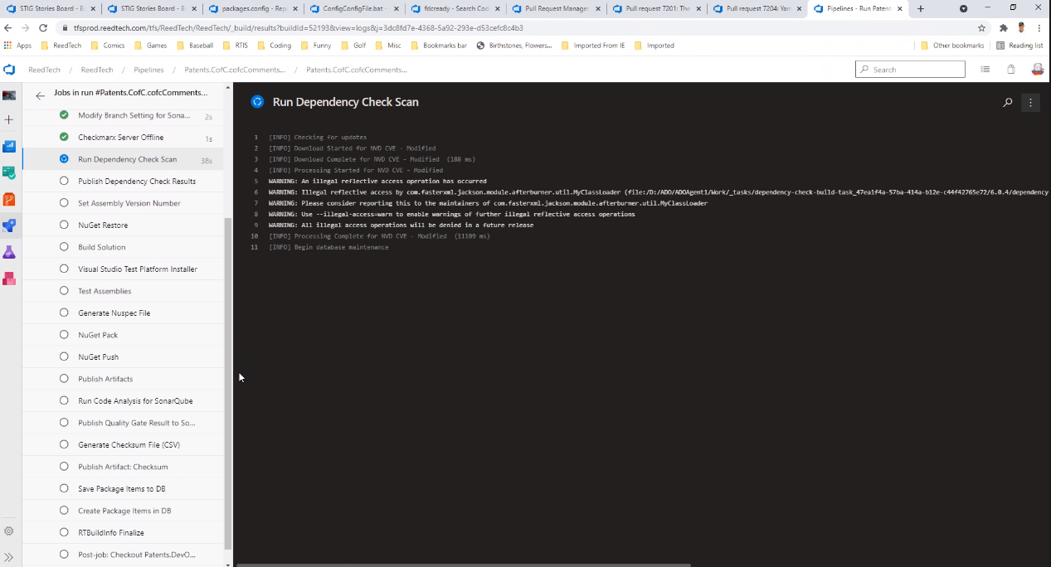

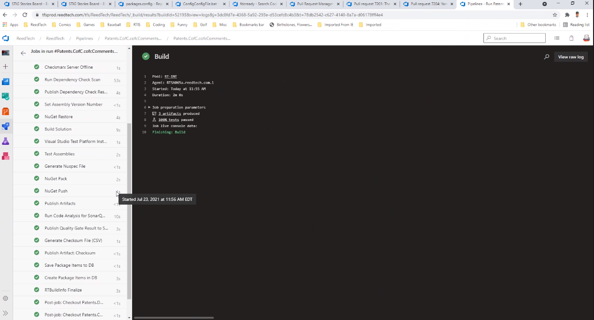

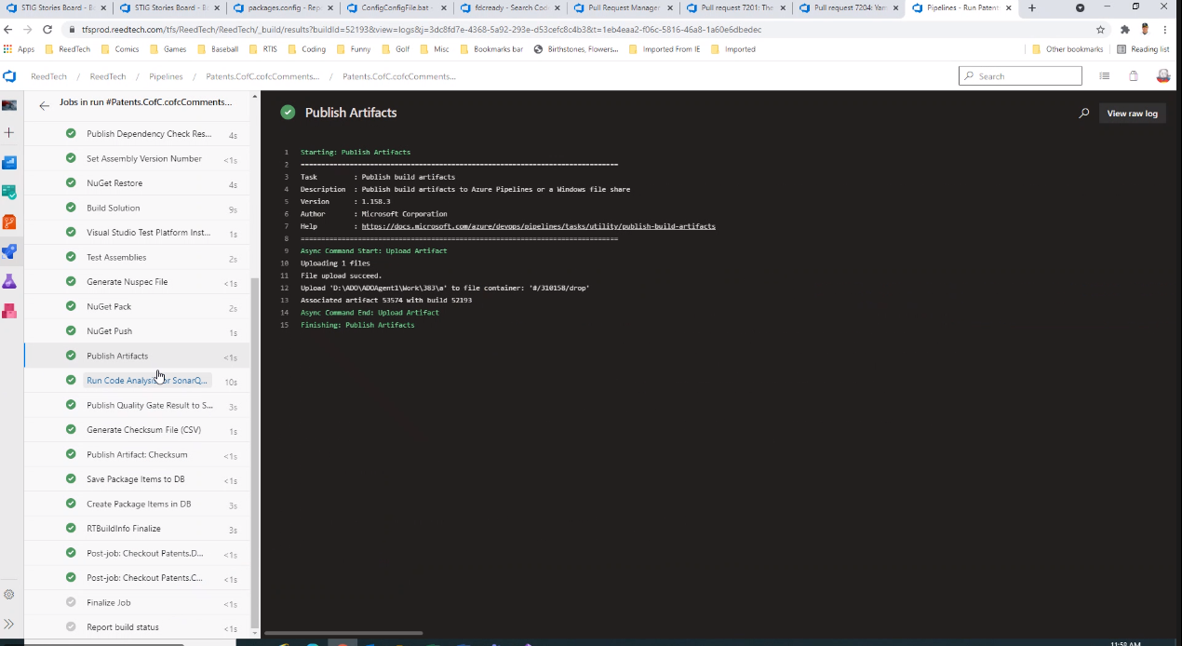

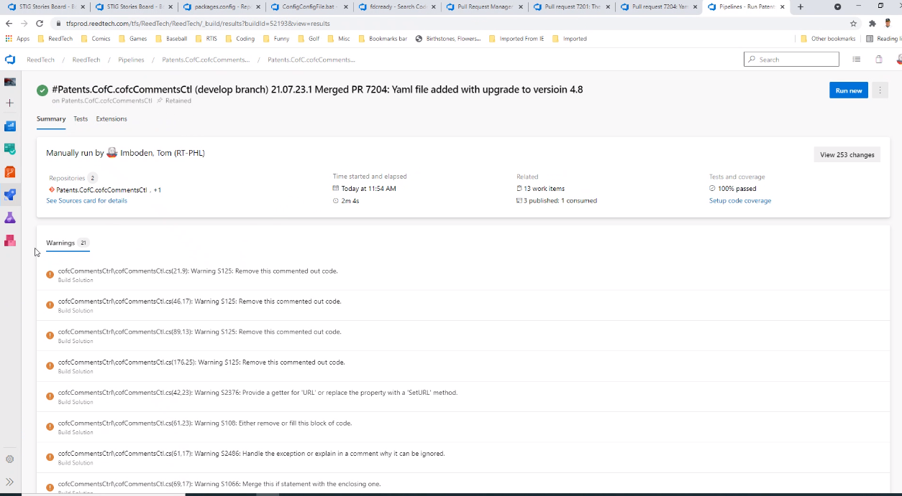

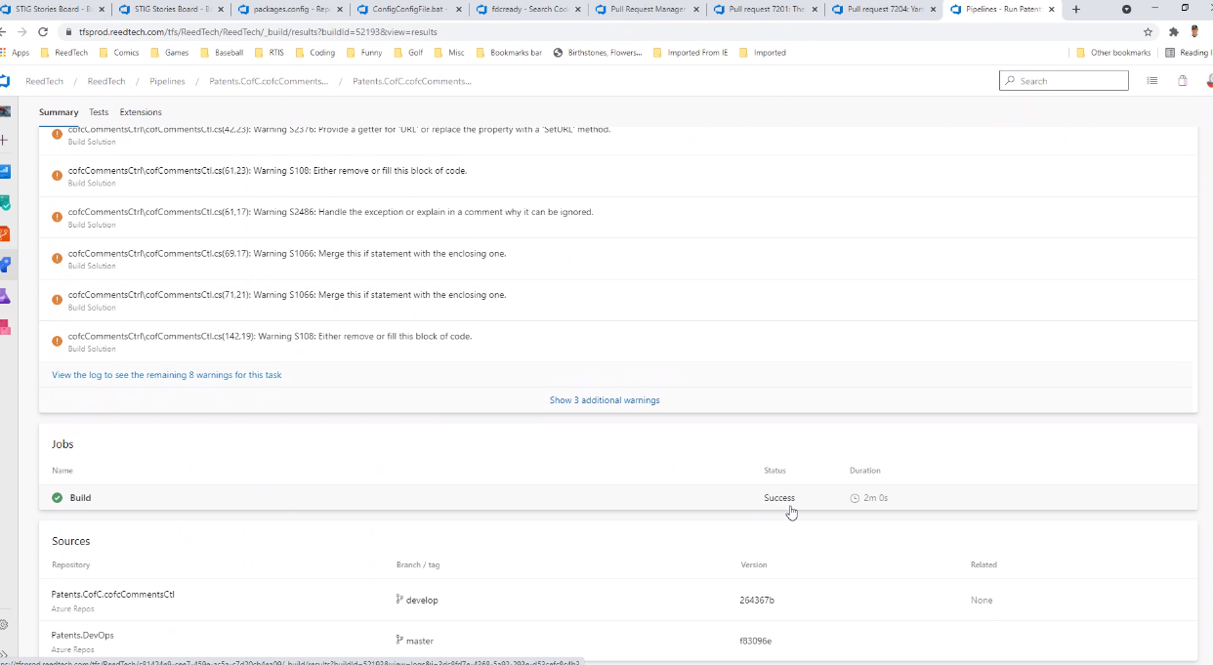

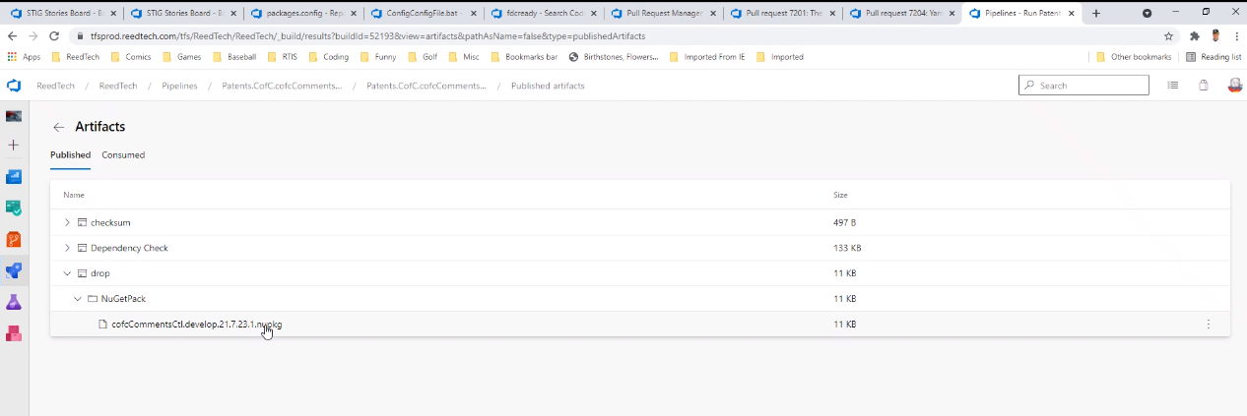

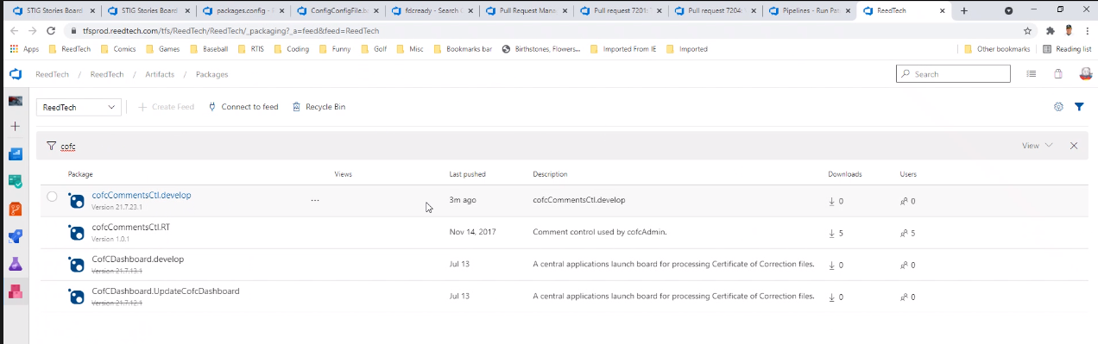

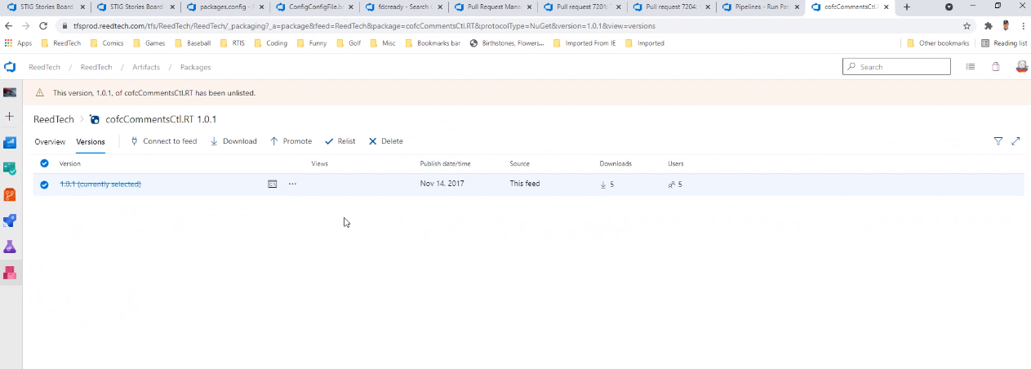

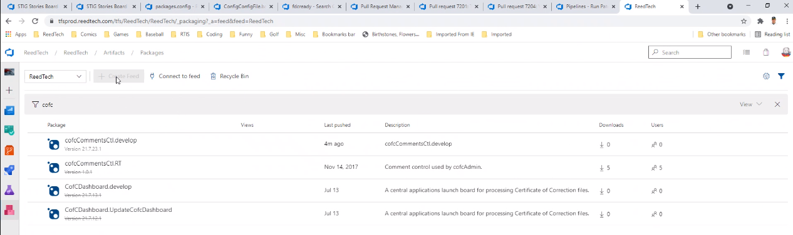

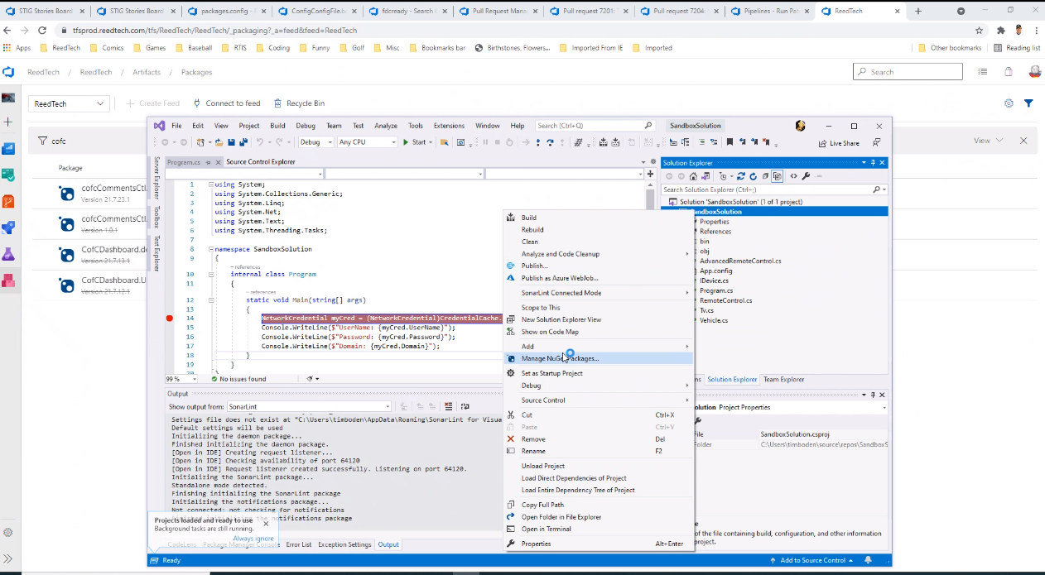

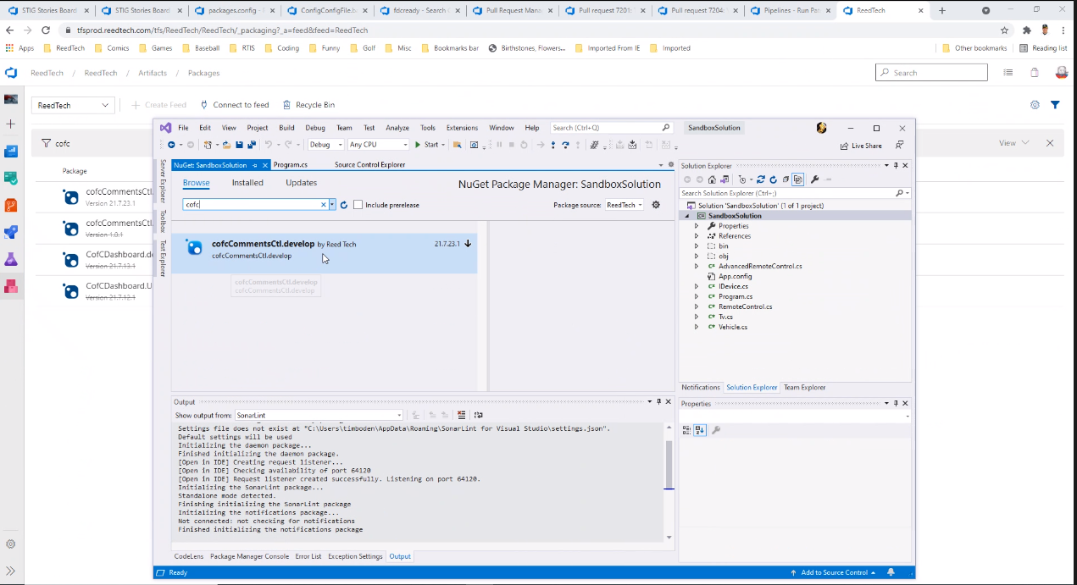

Probably need to upgrade the NuGet references to the new version

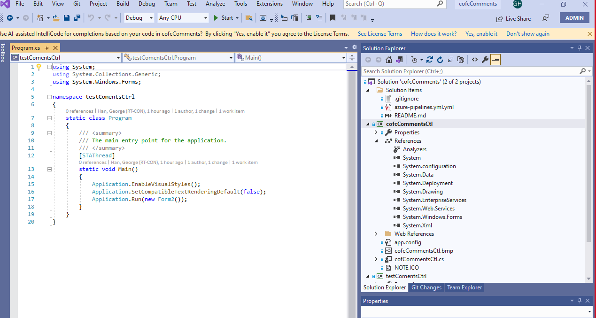

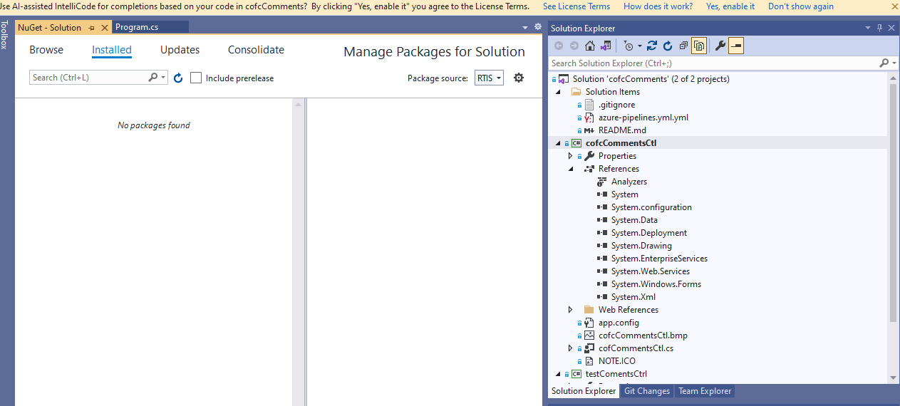

Last step:

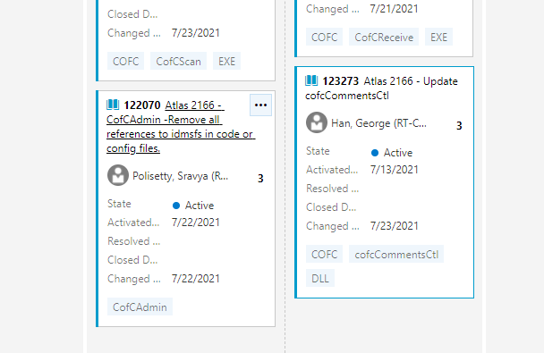

[123273](https://tfsprod.reedtech.com/tfs/ReedTech/ReedTech/_boards/board/t/STIG/Stories/?workitem=123273)